Year 8 |  | Volume | Non Calculator  Section
Skills and Knowledge Assessed:  - Draw different views of prisms and solids formed from combinations of prisms (ACMMG161)  - Choose appropriate units of measurement for area and volume and convert from one unit to another (ACMMG195)  - Develop the formulas for volumes of rectangular and triangular prisms and prisms in general. Use formulas to solve problems involving volume (ACMMG198)  - Calculate the surface area and volume of cylinders and solve related problems (ACMMG217) Extension |  |  | Name___________________
Answer all questions in the spaces provided on this test paper by:
Writing the answer in the box provided.
or
Shading in the bubble for the correct answer from the four choices provided.
Show any working out on the test paper. Calculators are not allowed.
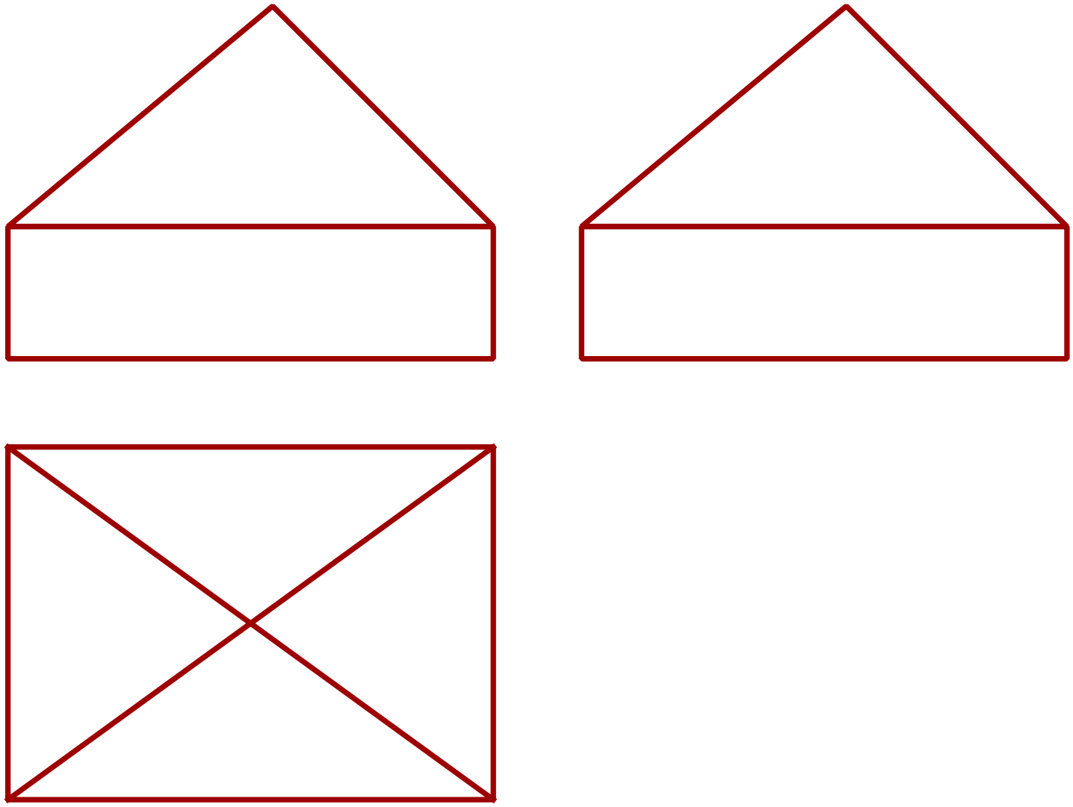Which diagram shows the three dimensional view of the solid whose plan and elevations are shown below.

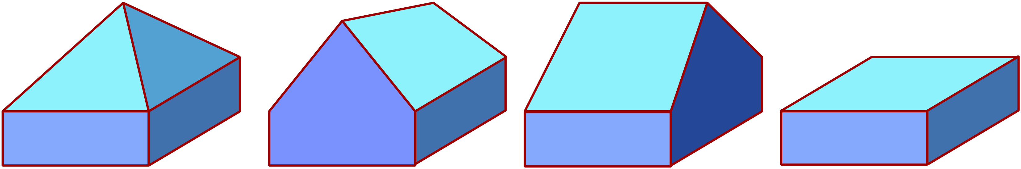

 | 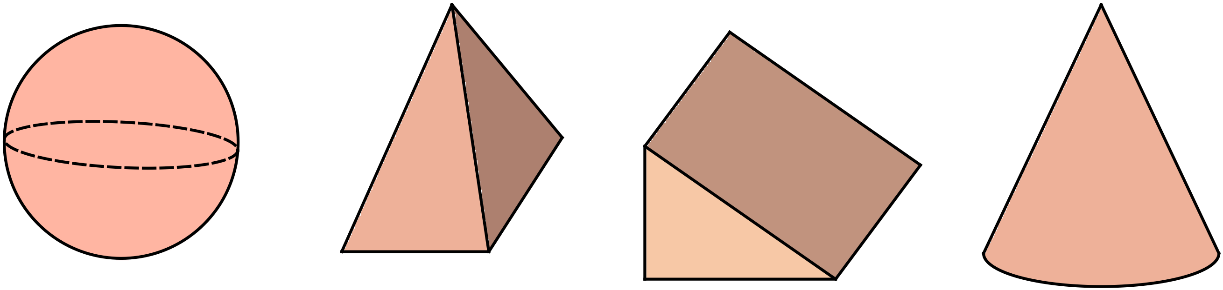Which solid below could be described as a prism?
 | 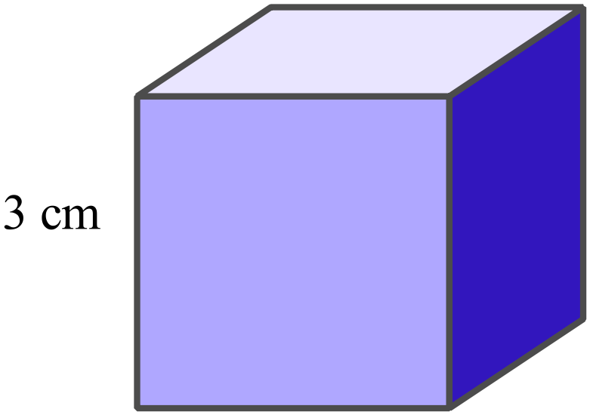What is the volume of the cube shown?
What is the volume of the rectangular prism?
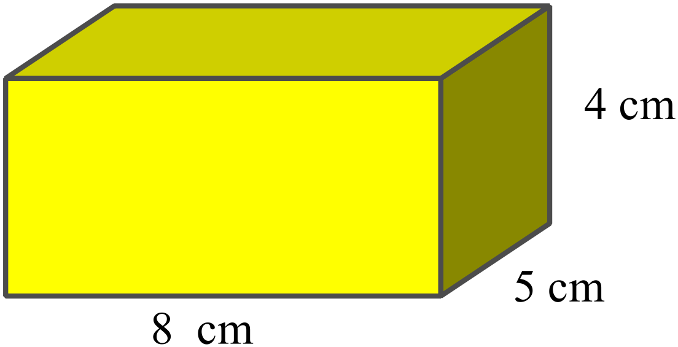

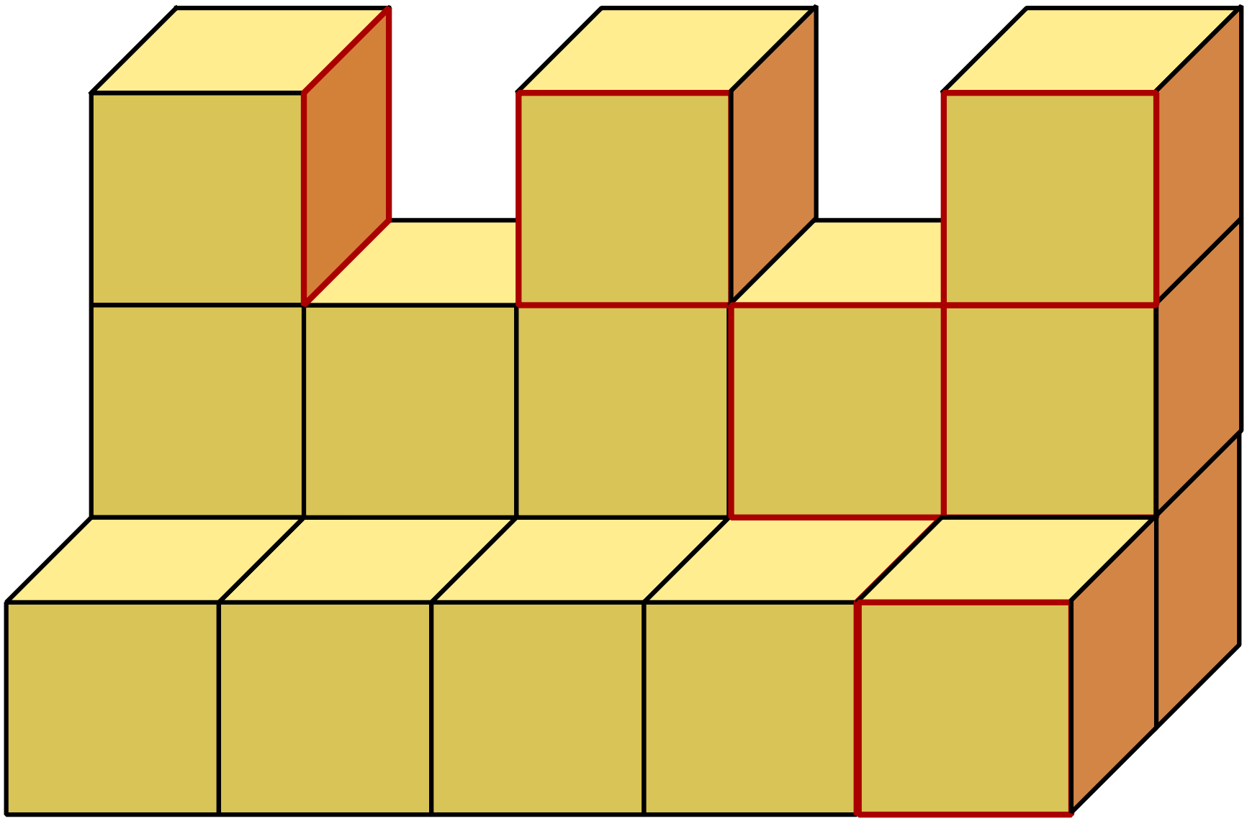The solid is made by joining centimetre cubes together.
What is the volume of the solid?

How many cubic centimetres are there in a cubic metre?
1 000
10 000
100 000
1 000 000
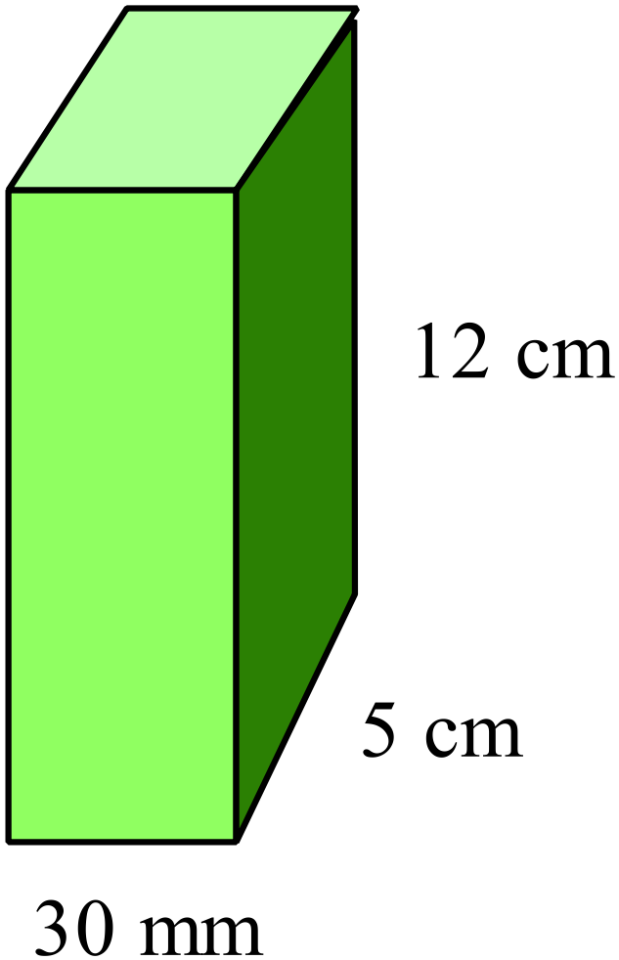What is the volume of the prism shown in cm³?

18 cm³
180 cm³
1 800 cm³
18 000 cm³

Find the volume of the triangular prism shown.
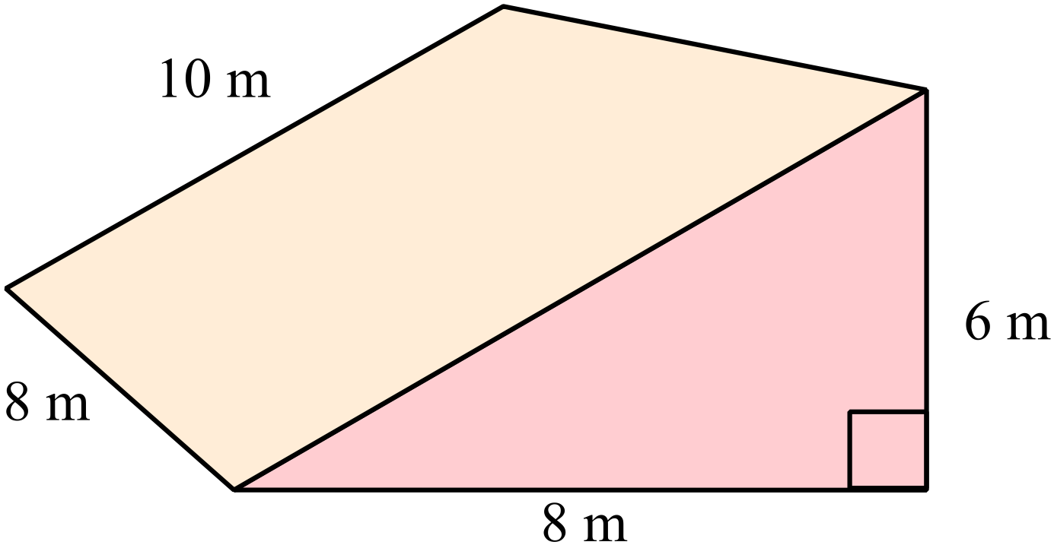

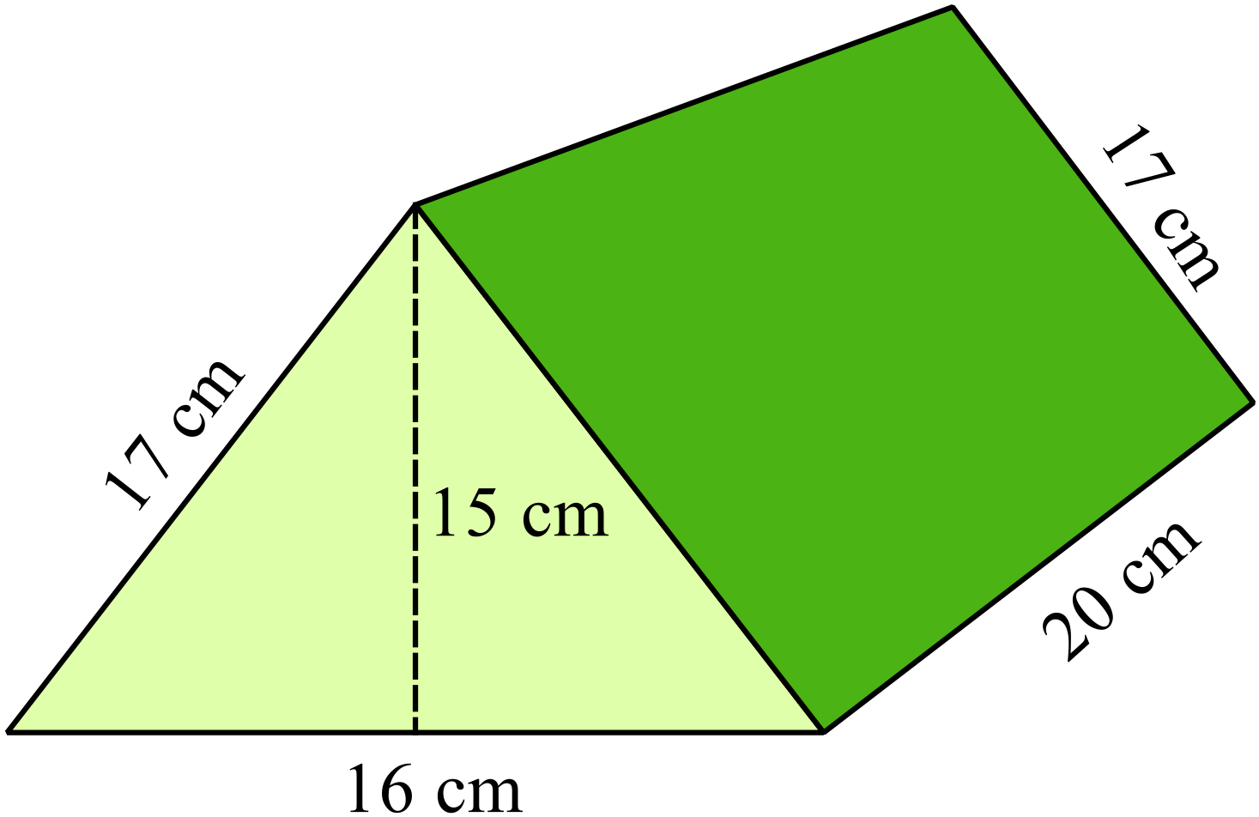What is the volume of the triangular prism shown?

1 360 m³
2 400 m³
2 720 m³
4 800 m³

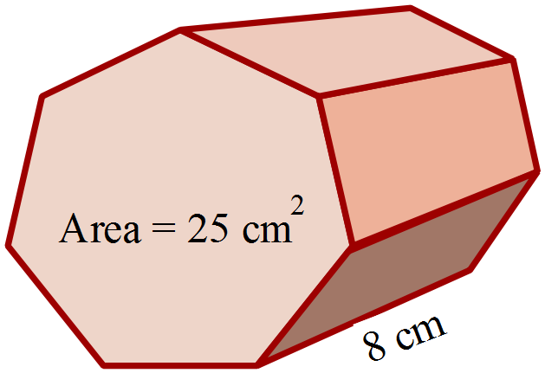The area of the heptagonal base of this prism is 25 cm².
What is the volume of the prism?

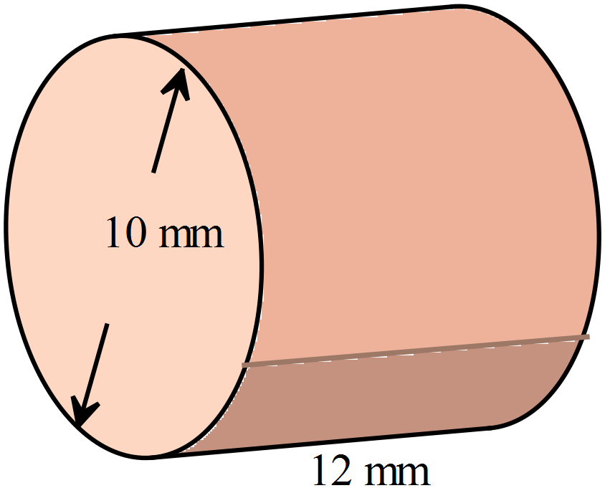What is the volume of the cylinder, in terms of 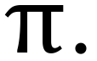

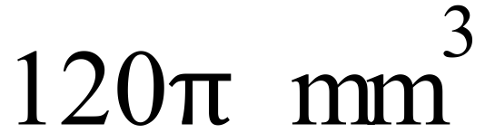
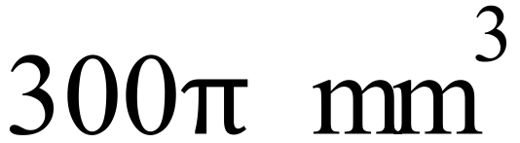
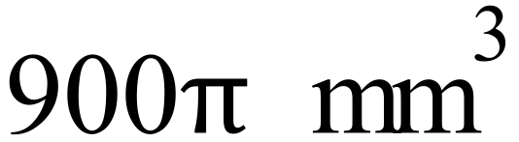
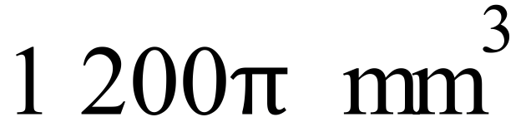

What is the volume of the prism whose net is shown here?
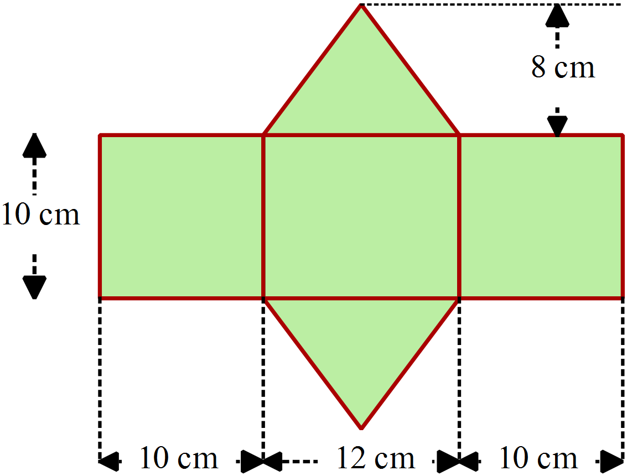

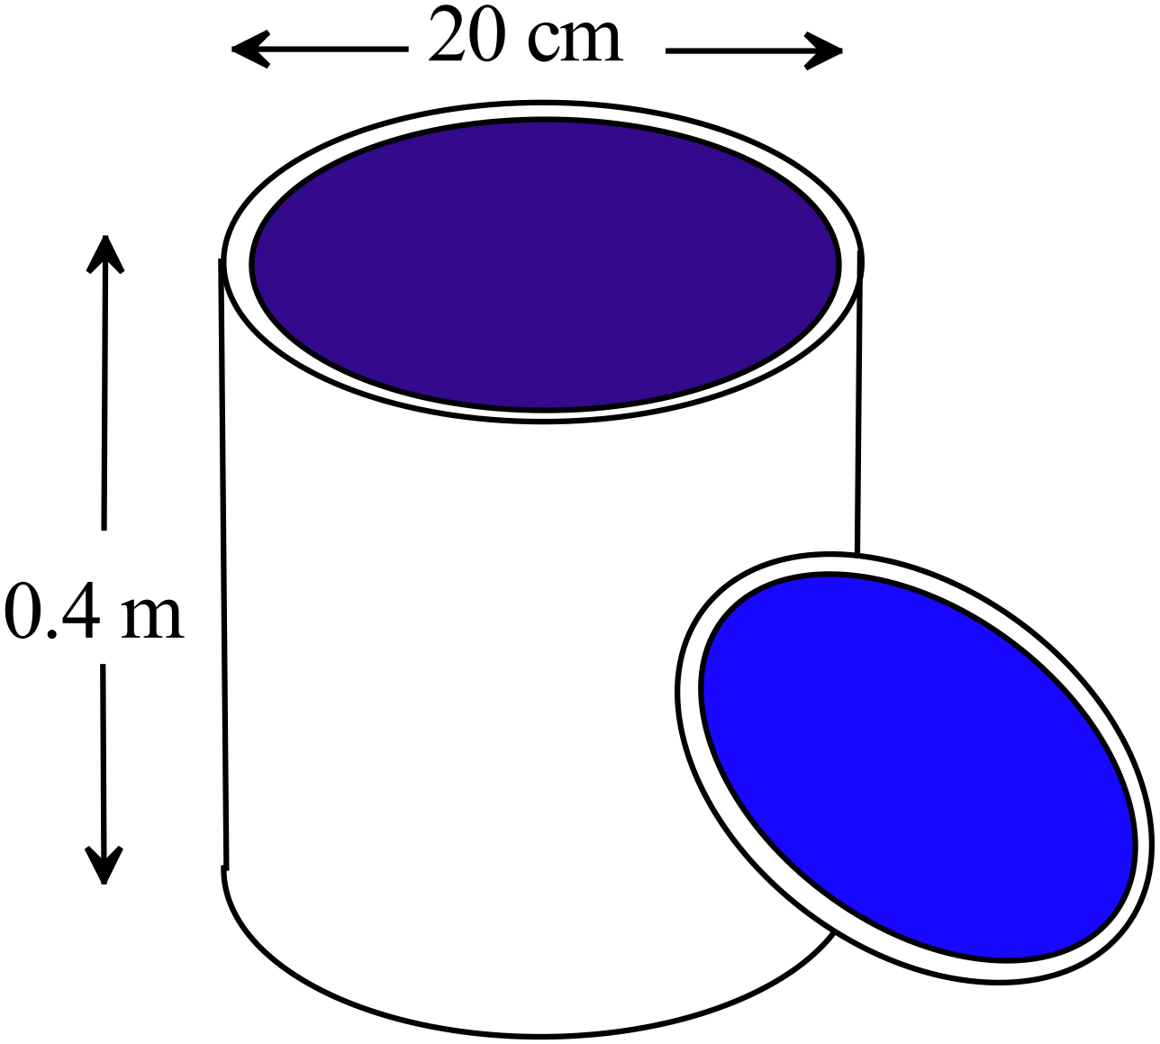What volume of paint would the cylindrical can hold.
Answer in cm³ and in terms of

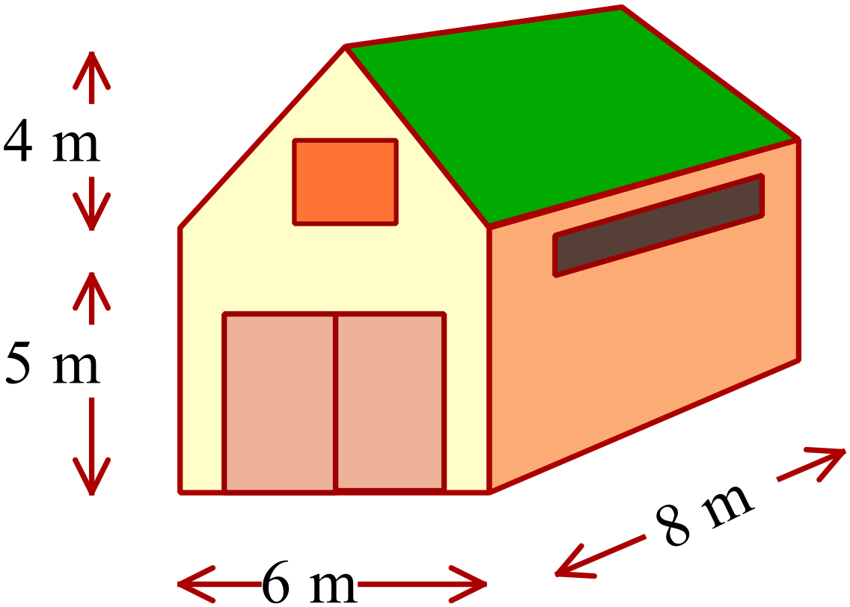A barn has the dimensions shown.
Calculate the volume of the barn in cubic metres.

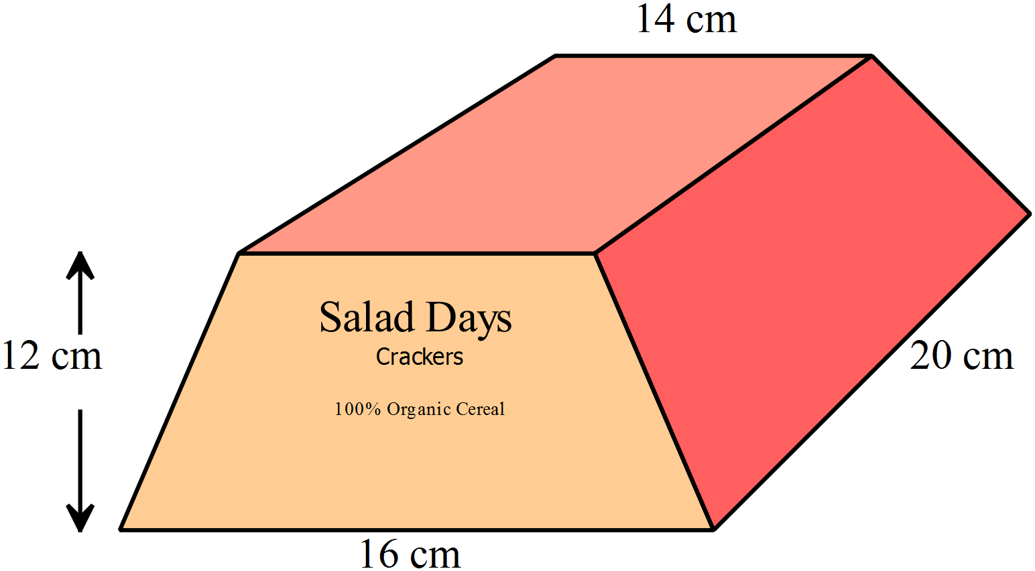A food package is in the form of a trapezoidal prism.
The dimensions are shown.
Find the volume of the package.

Year 8 |  | Volume | Calculator Allowed  Short Answer  Section
 |  |  | Name___________________
Answer all questions in the spaces provided on this test paper by:
Writing the answer in the box provided.
or
Shading in the bubble for the correct answer from the four choices provided.
Show any working out on this test paper. Calculators are allowed.
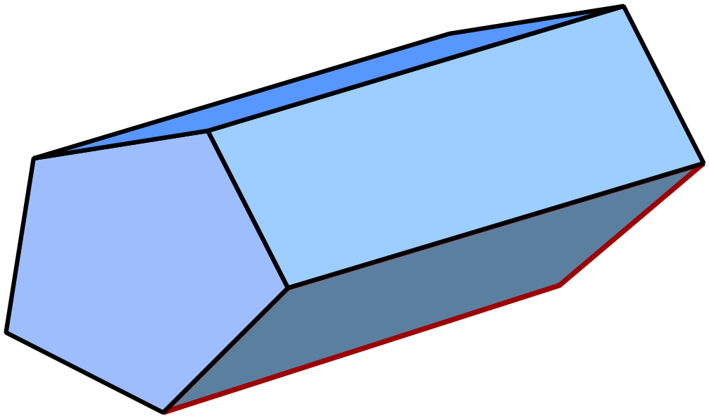What name could be given to the solid below?

Hexagonal prism
Hexagonal pyramid
Pentagonal prism.
Pentagonal pyramid.
What name would be given to a solid whose net is shown below?
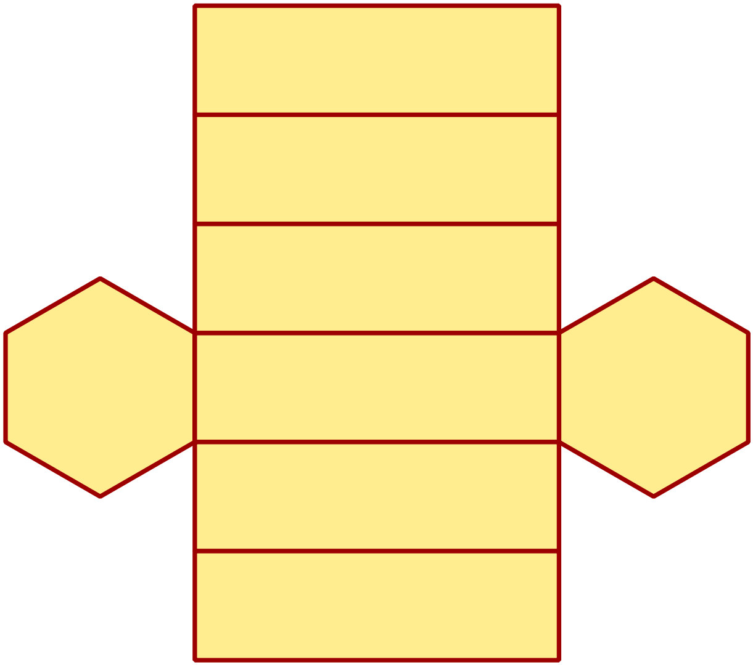

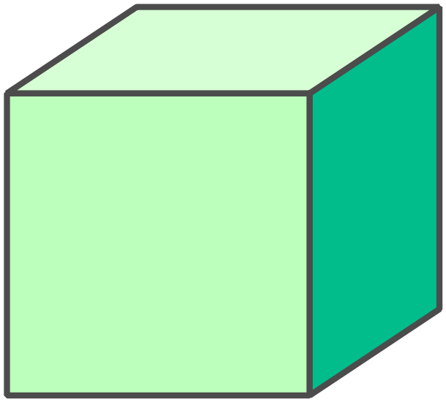A cube has a volume of 17.576 cm³?
What is its side length?

2.6 cm
4.2 cm
5.8 cm
8.8 cm
What is the volume of the rectangular prism?
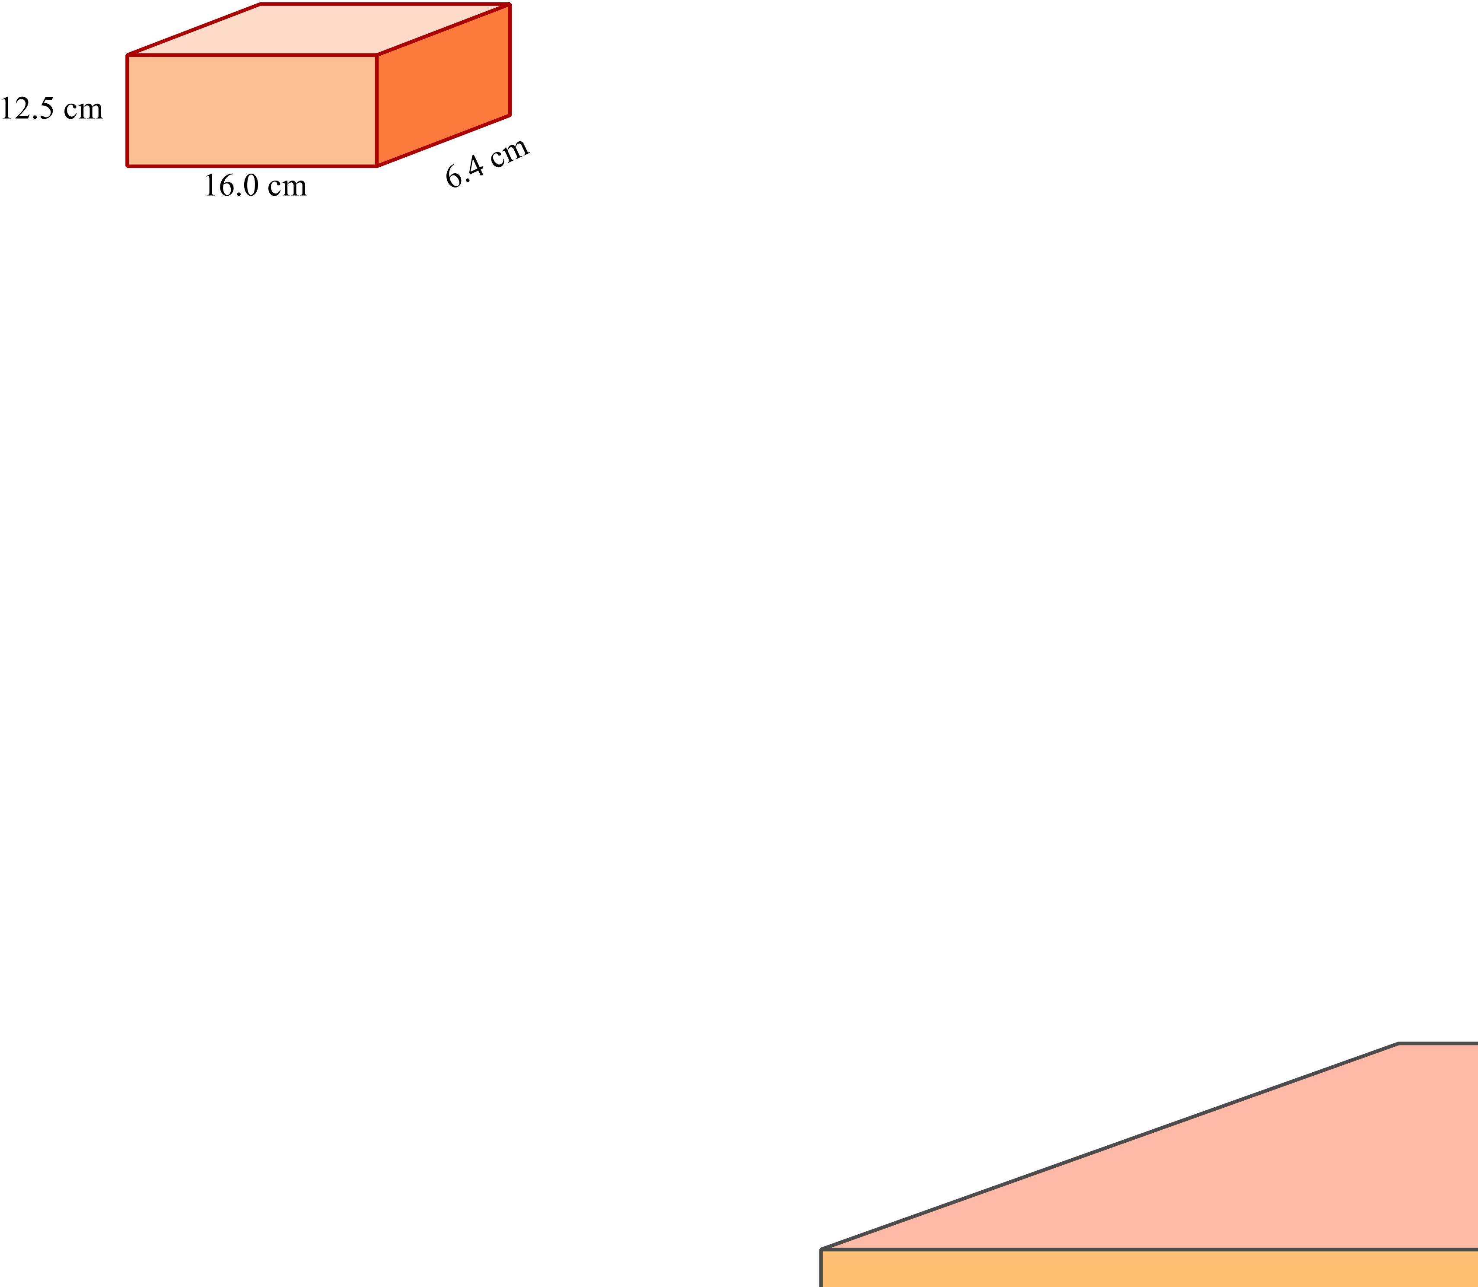

 | 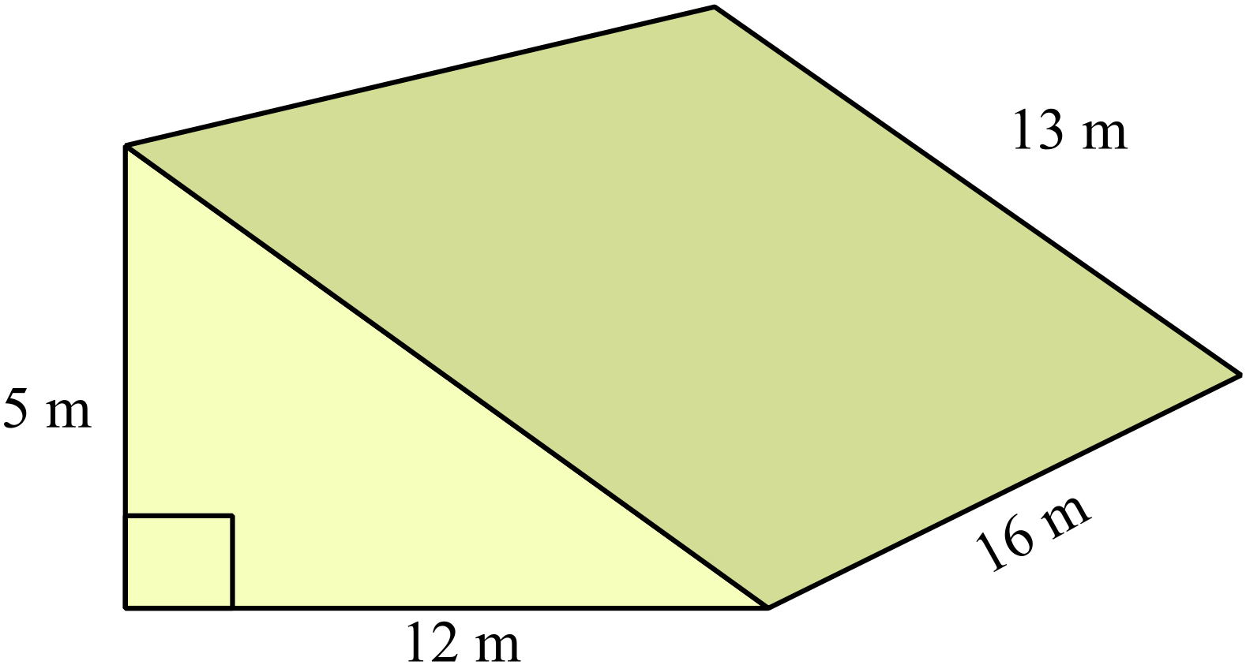Find the volume of the triangular prism shown.
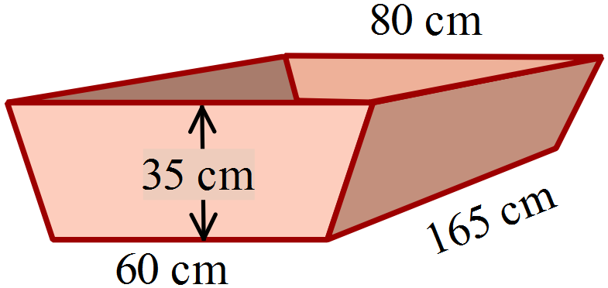A water trough is in the shape of a trapezoidal prism.
It is 35 cm deep and 165 cm long.
What is its volume, correct to the nearest cm³?

186 450 cm³
404 250 cm³
606 375cm³
808 500 cm³
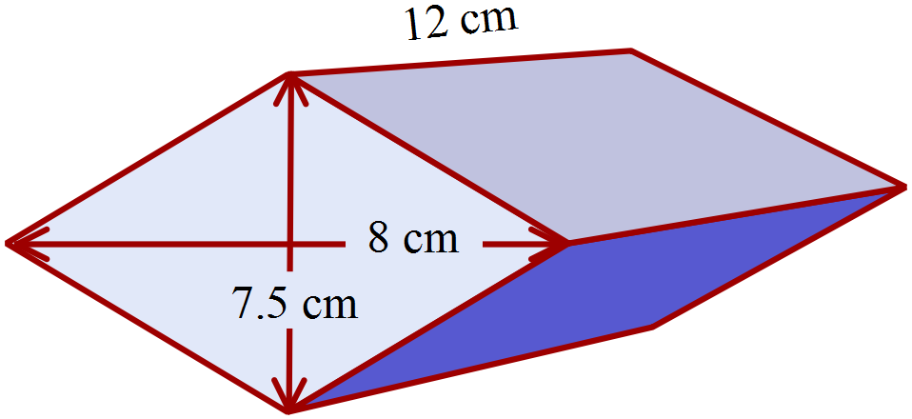The prism has a rhombus as its base.
What is its volume?

30 cm³
90 cm³
180 cm³
360 cm³
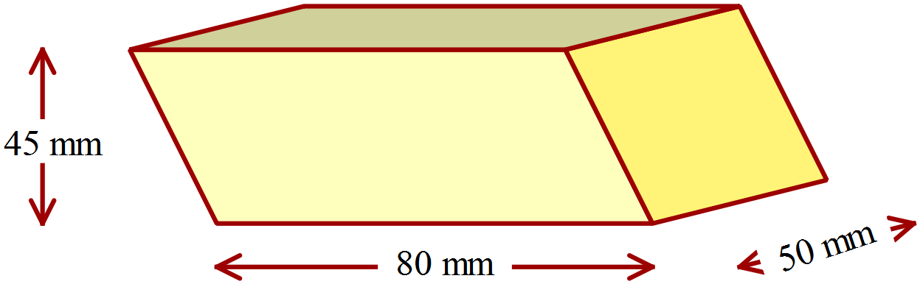An eraser is in the shape of a prism with a parallelogram as its cross section.
What is the volume of the eraser in mm³?

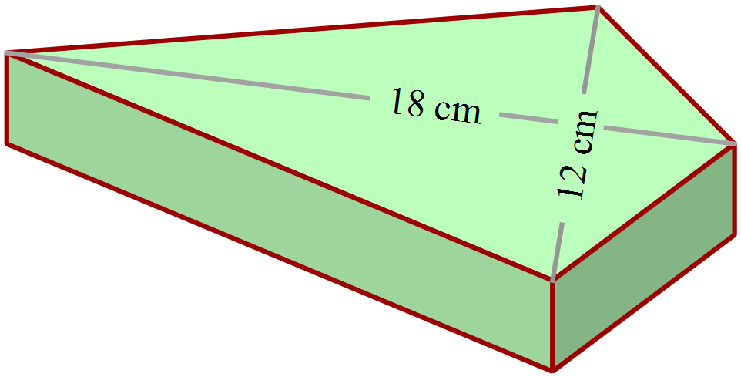A paperweight is a prism with a face in the shape of a kite, as shown.
It is 3 cm thick and made of glass.
What volume of glass is used to make the paperweight?

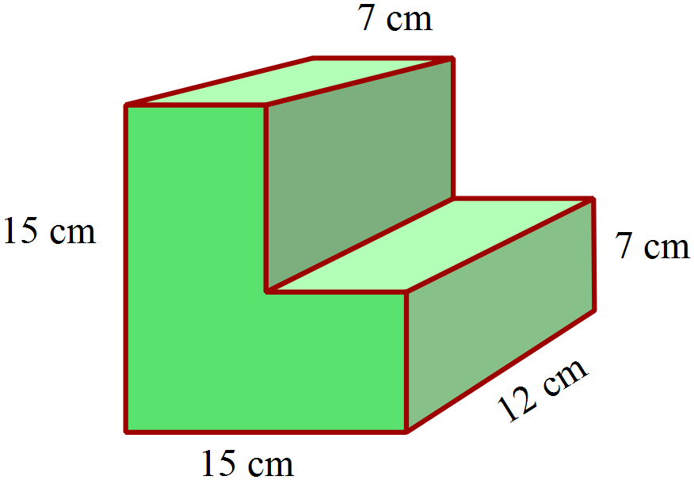What is the volume of the solid shown?

161 cm³
966 cm³
1 932 cm³
2 112 cm³

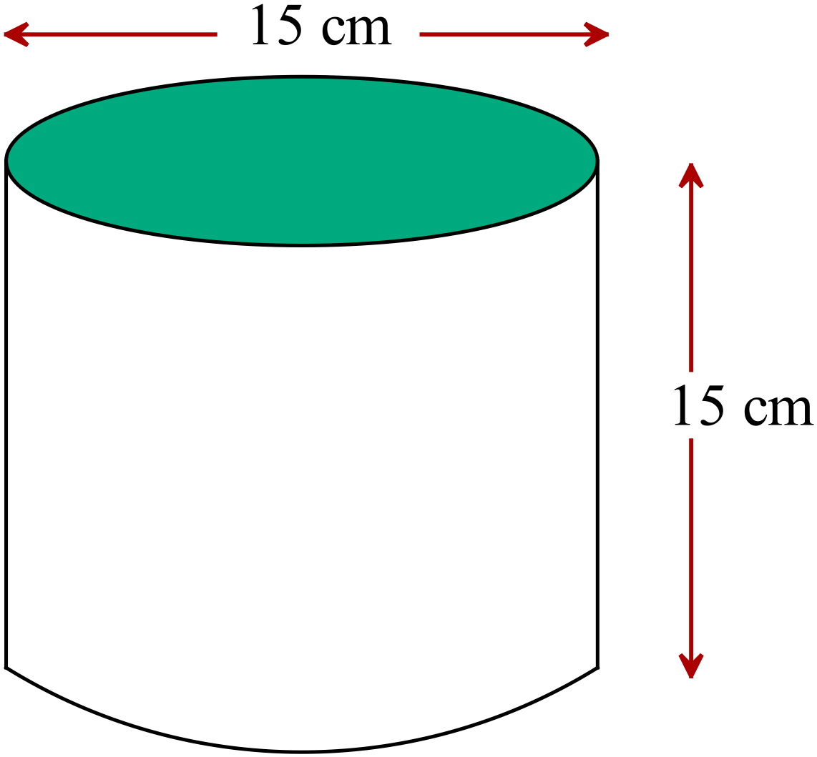What is the volume of the cylinder to the nearest cm³?

707 cm³
2 651 cm³
5 301 cm³
10 603 cm³

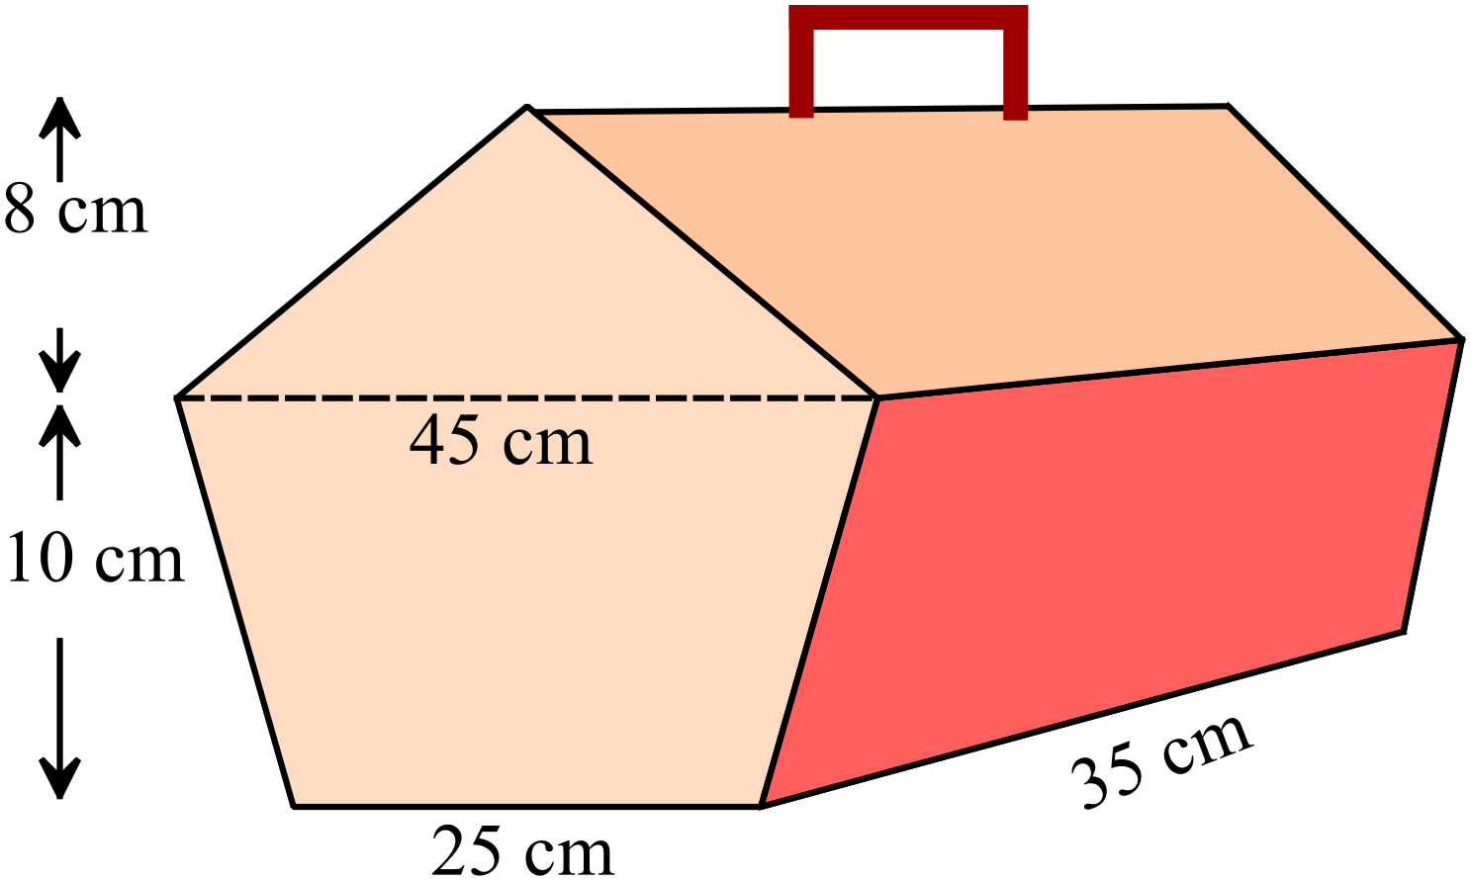The diagram shows a picnic hamper.
Find the volume of the hamper?

18 550 cm³
24 850 cm³
30 800 cm³
37 100 cm³
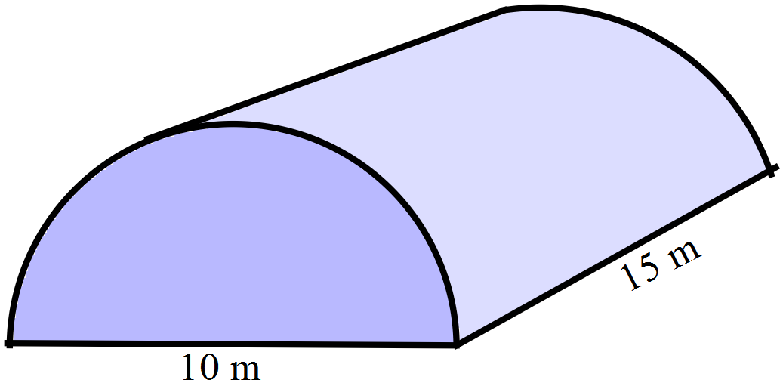A storage hut is in the shape of a half cylinder.
The diameter of the semicircle is 10 metres and the length of the hut is 15 metres.
What is its volume to the nearest cubic metre?

 | 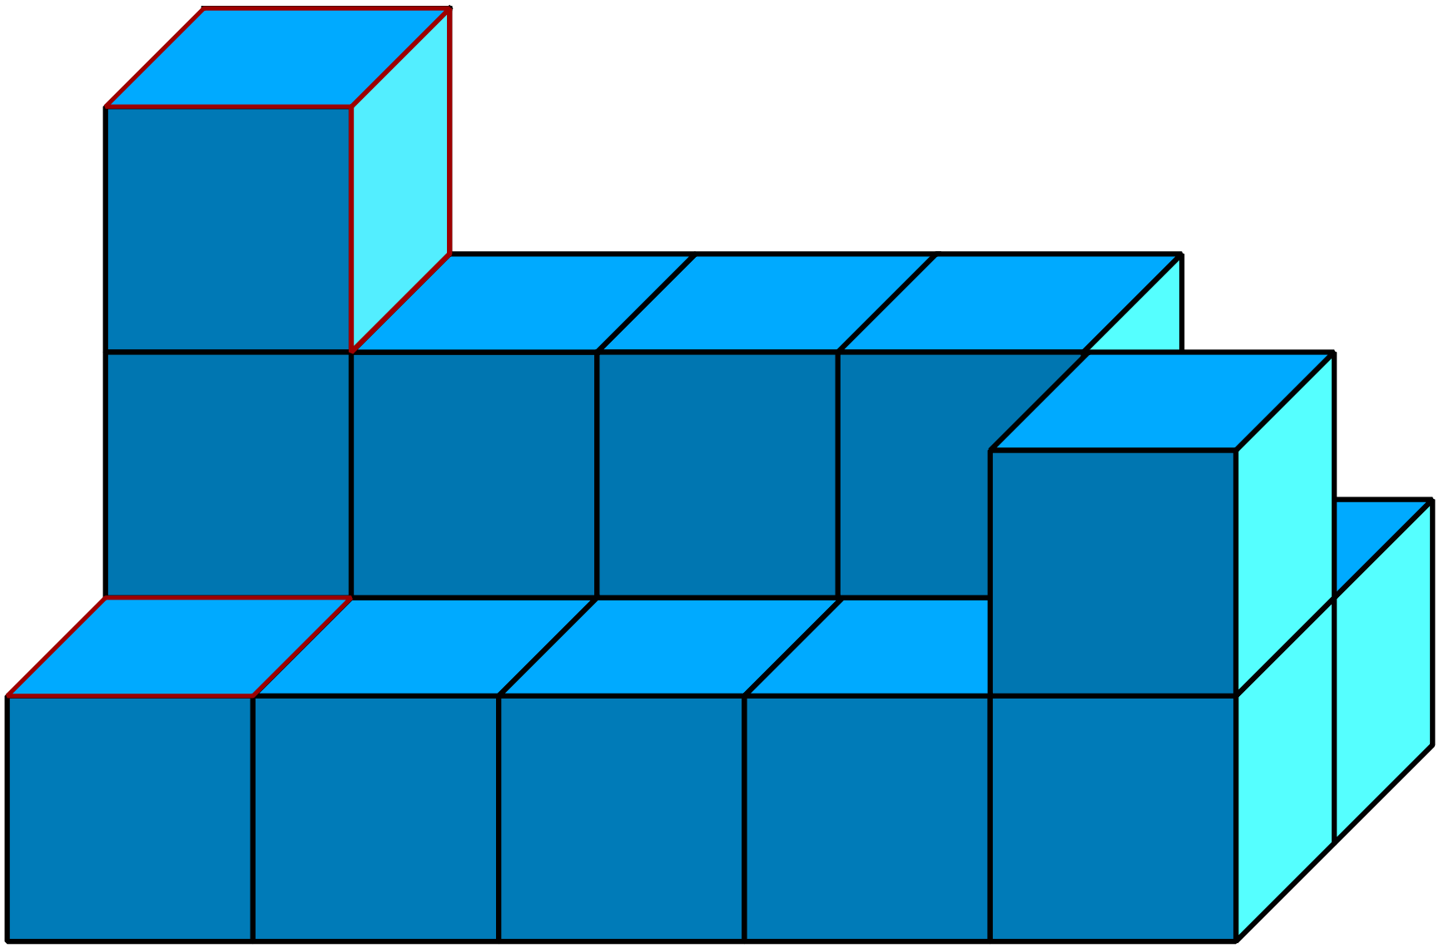Jack is building a prism from 1 cm² cubes. What is the least number of cubes he must add to produce a prism?
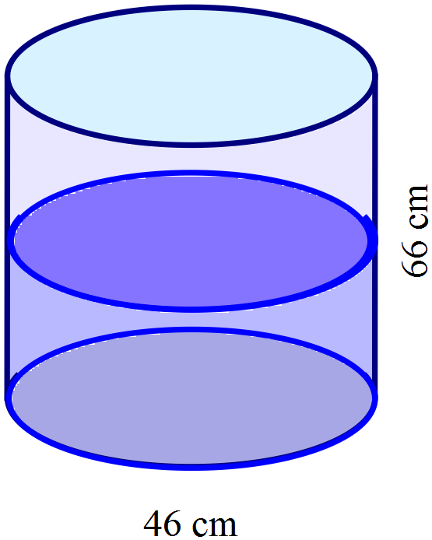A cylindrical water cooler is 66 cm high and has a diameter of 46 cm.
It is currently half full, and is used to fill cups that hold 400 ml.
Given that 1000 cm³ holds 1 litre, how many more cups could be filled from the cooler?

Year 8 |  | Volume | Non Calculator  Section
ANSWERS
No. | WORKING |  | ANSWER
 | 1st has pyramid above a prism |  | 1st answer
 | 3rd is a triangular prism |  | 3rd answer
 | 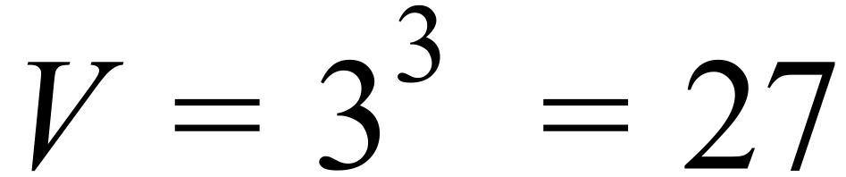 |  | 27 cm³
 | 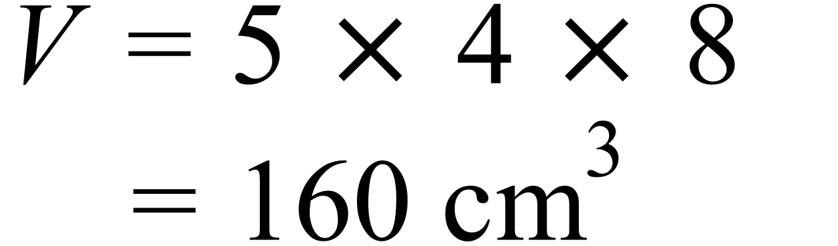 |  | 160 cm³
 | Bottom row = 10 cm³  Second row = 5 cm³  Top row = 3 cm³  Total volume = 18 cm³ |  | 18 cm³
 | 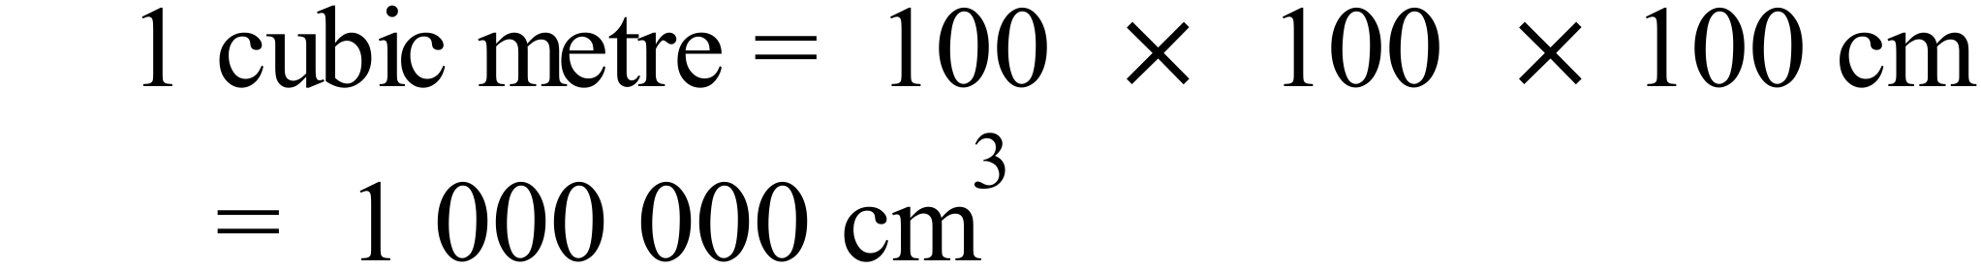 |  | 4th answer
 | 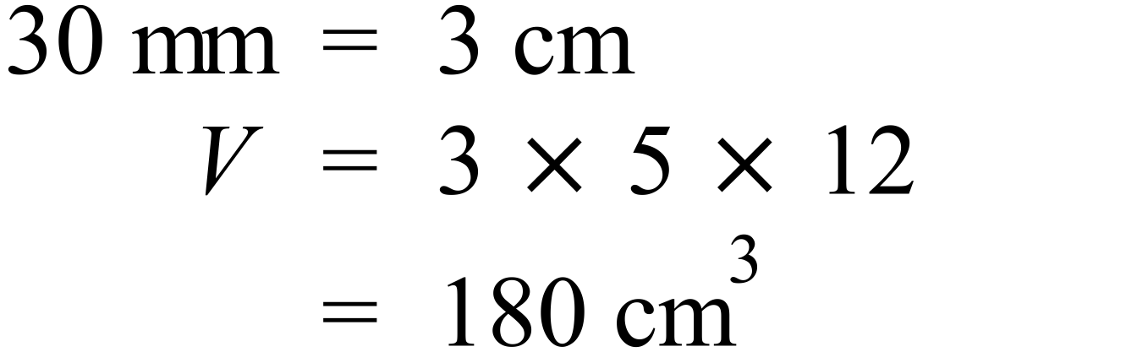 |  | 2nd answer
 | 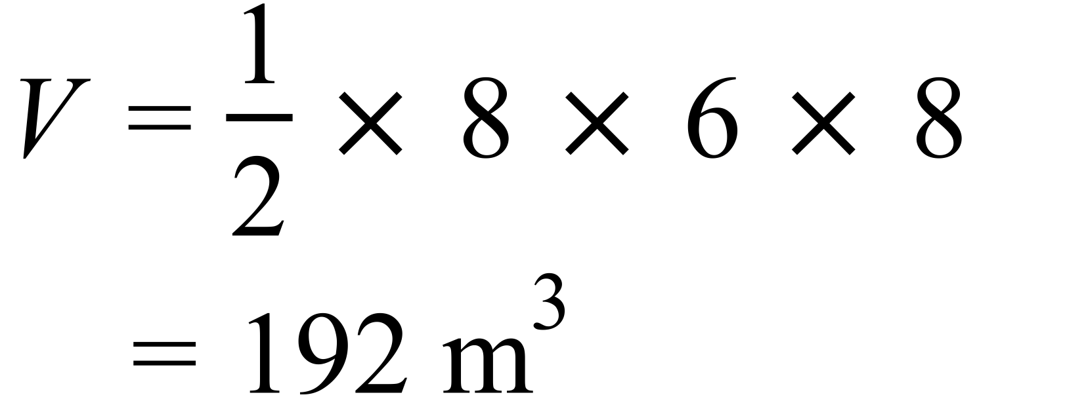 |  | 192 m³
 | 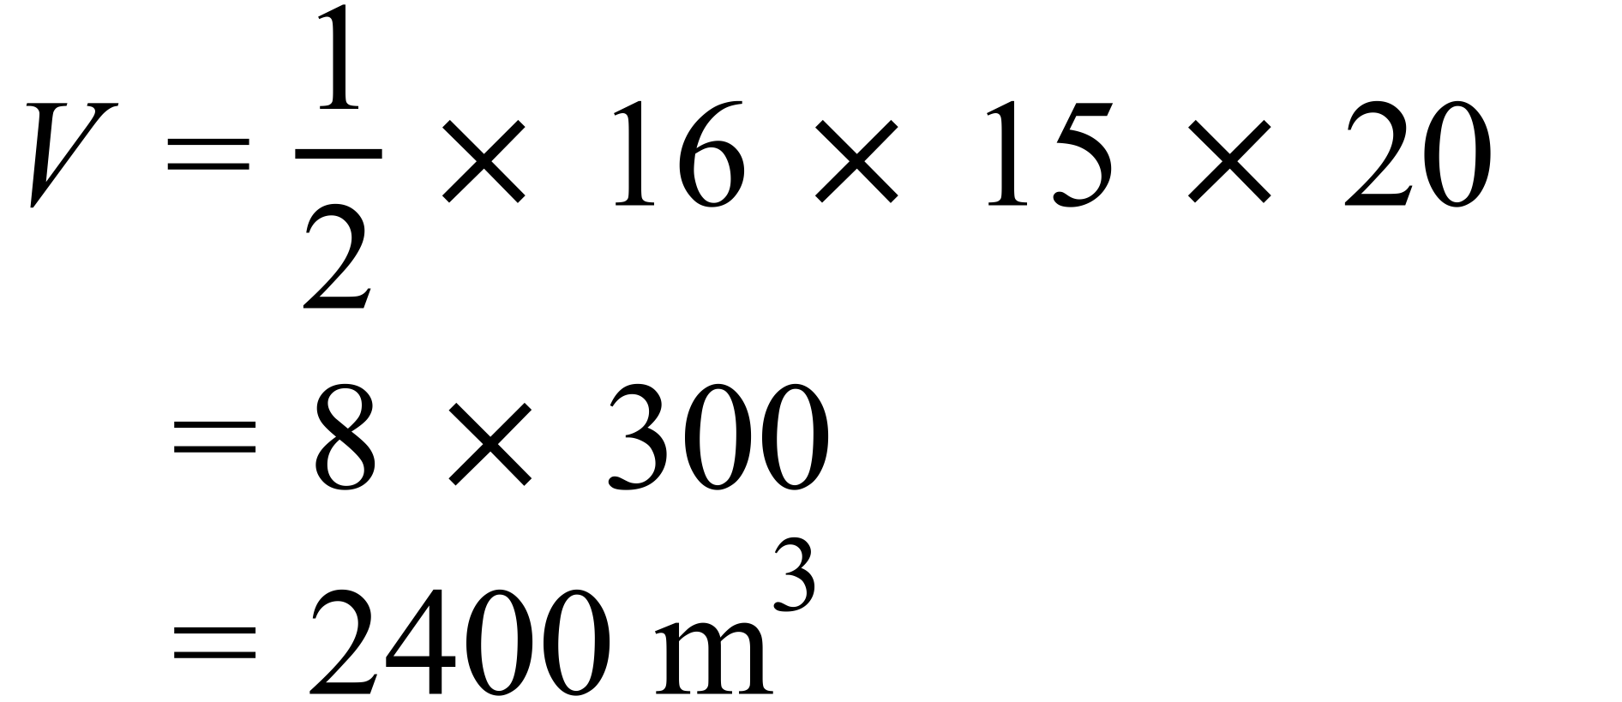 |  | 1st answer
 | 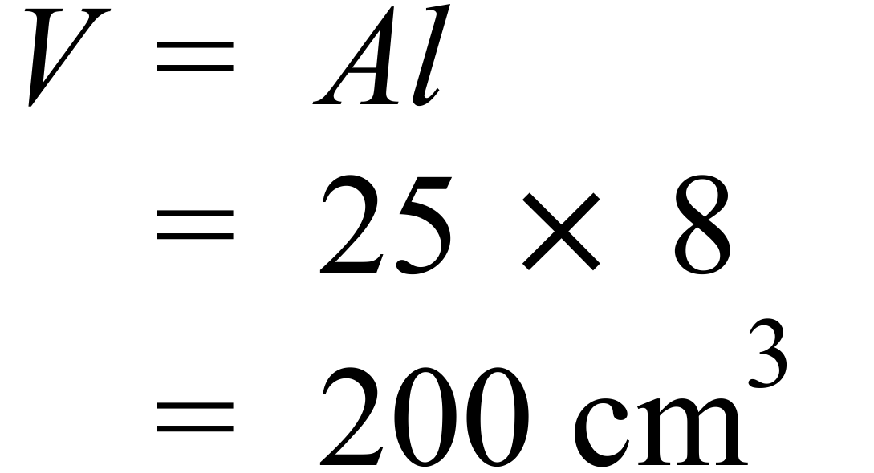 |  | 200 cm³
 | 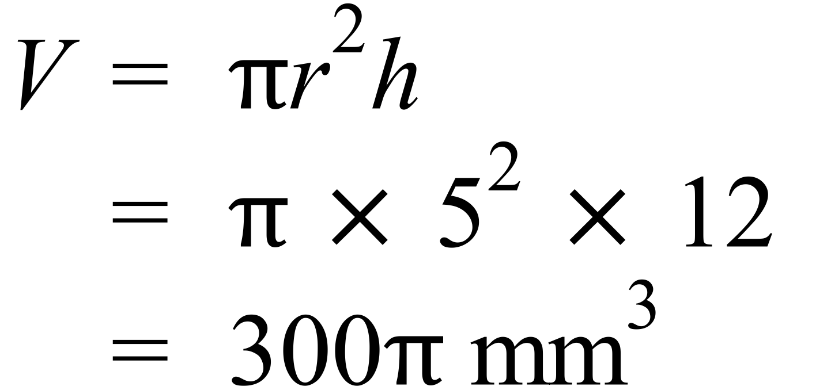 |  | 2nd answer
 | 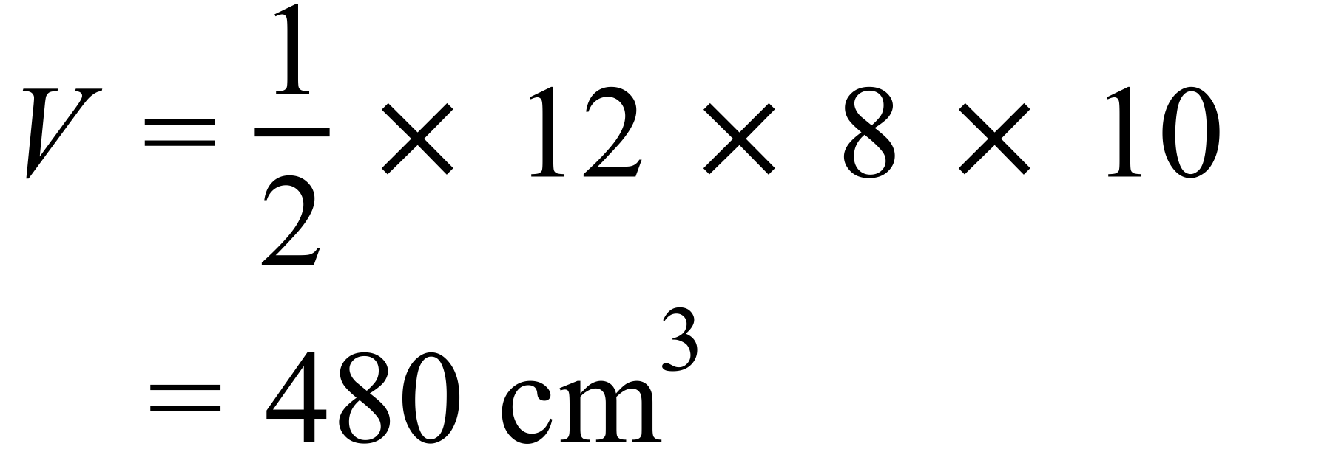 |  | 480 cm³
 | 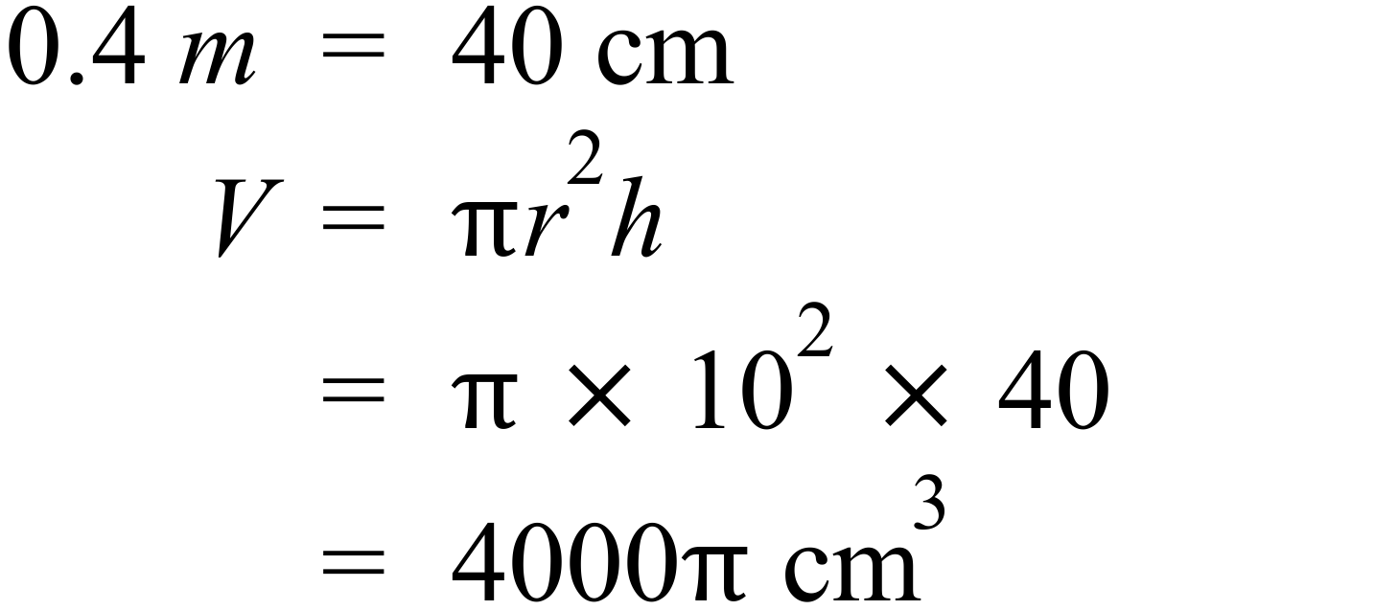 |  | 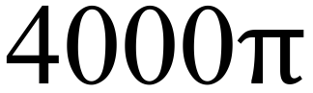 cm³
 | 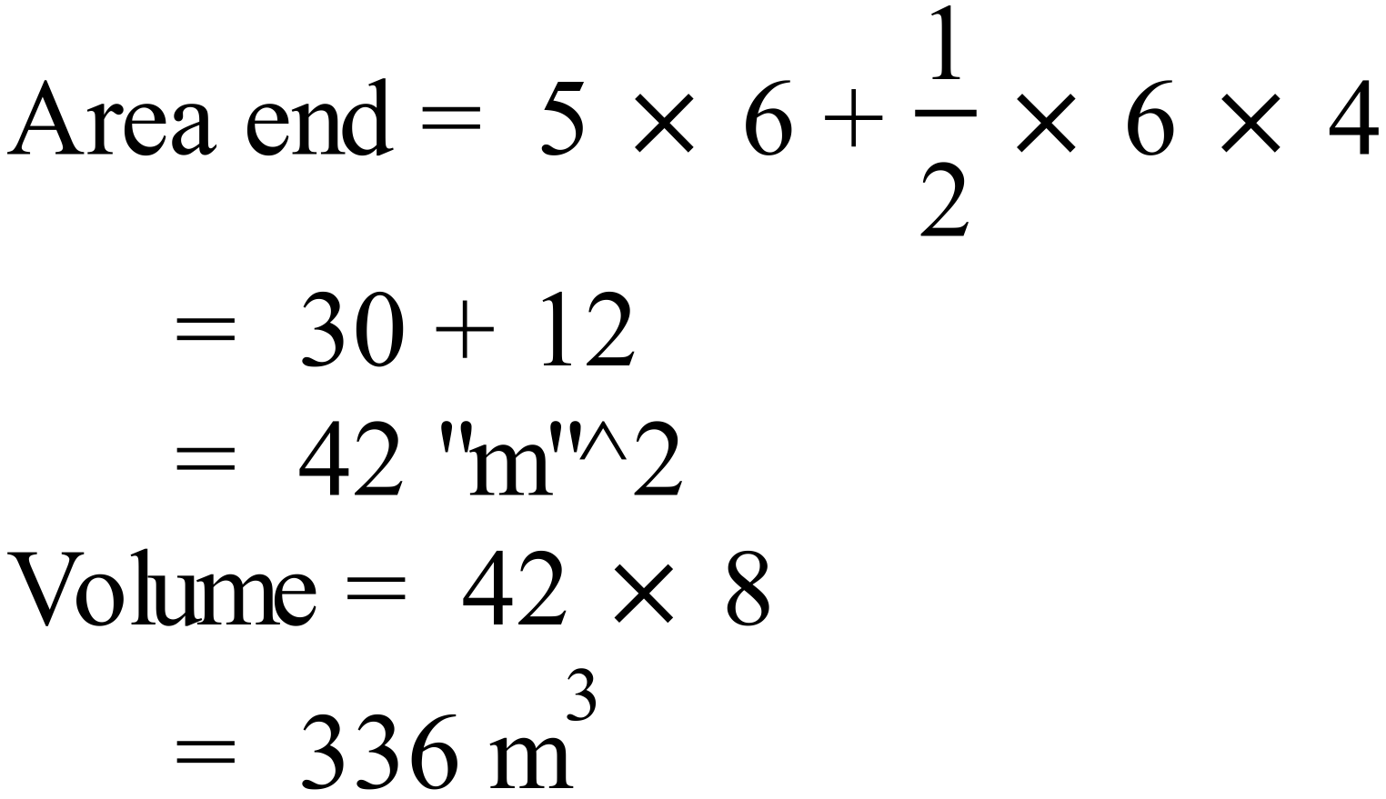 |  | 336 m³
 | 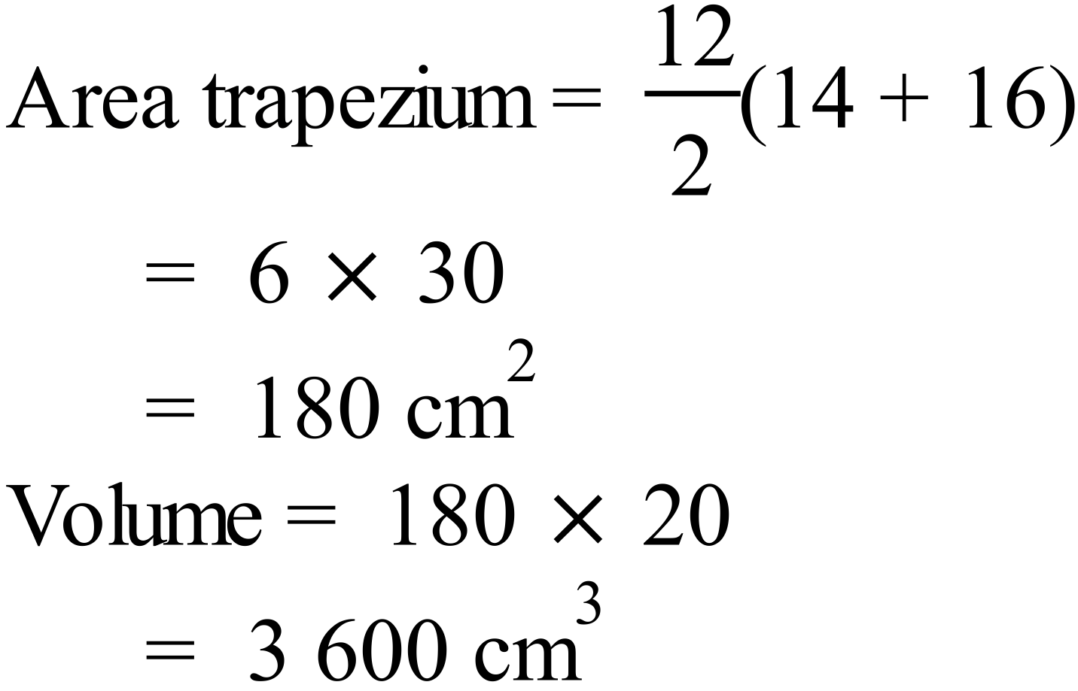 |  | 3 600 cm³

Year 8 |  | Volume | Calculator Allowed  Short Answer  Section
ANSWERS
No. | WORKING |  |  | ANSWER
 | It is a Pentagonal prism. |  |  | 3rd answer
 | Hexagonal prism |  |  | Hexagonal prism
 | 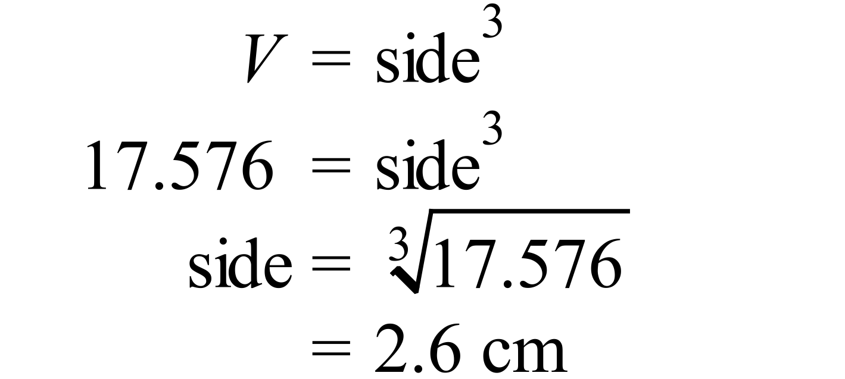 |  |  | 1st answer
 | 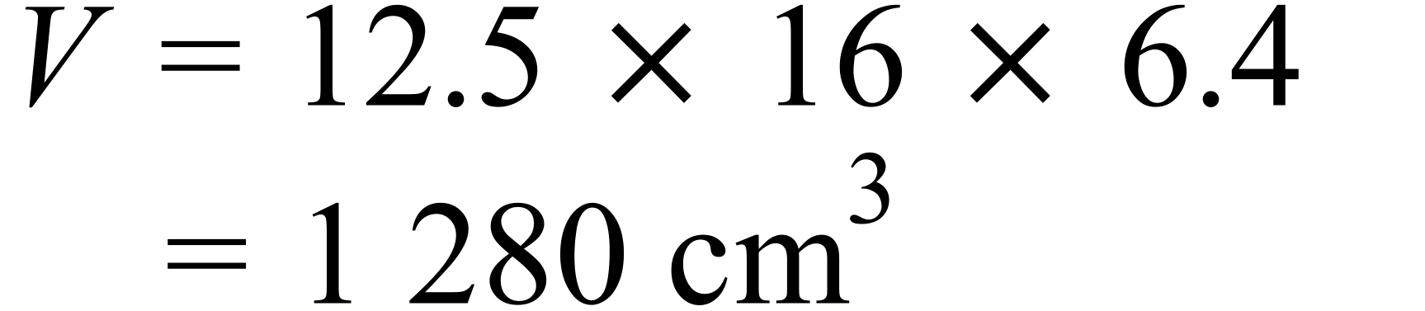 |  |  | 1 280 cm³
 | 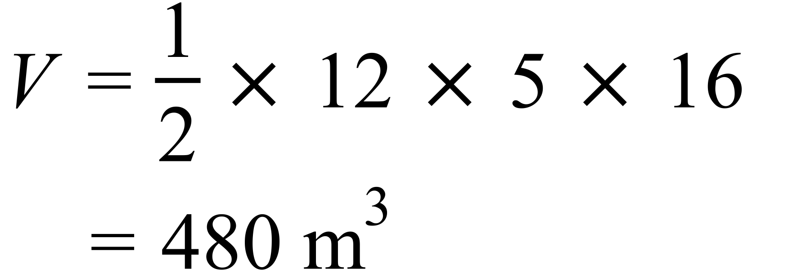 |  |  | 480 m³
 | 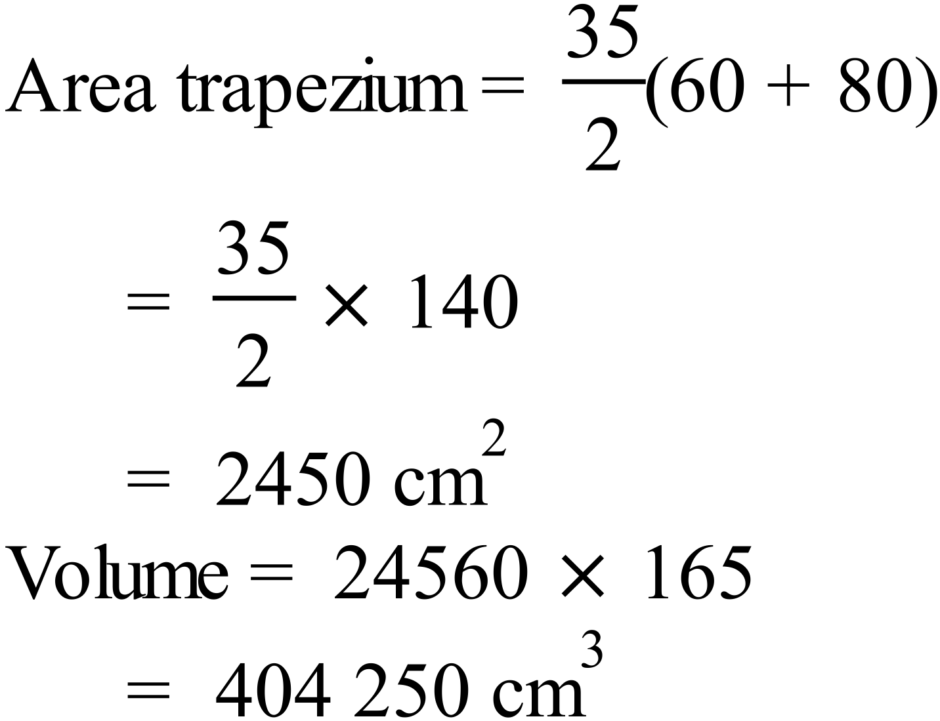 |  |  | 2nd answer
 | 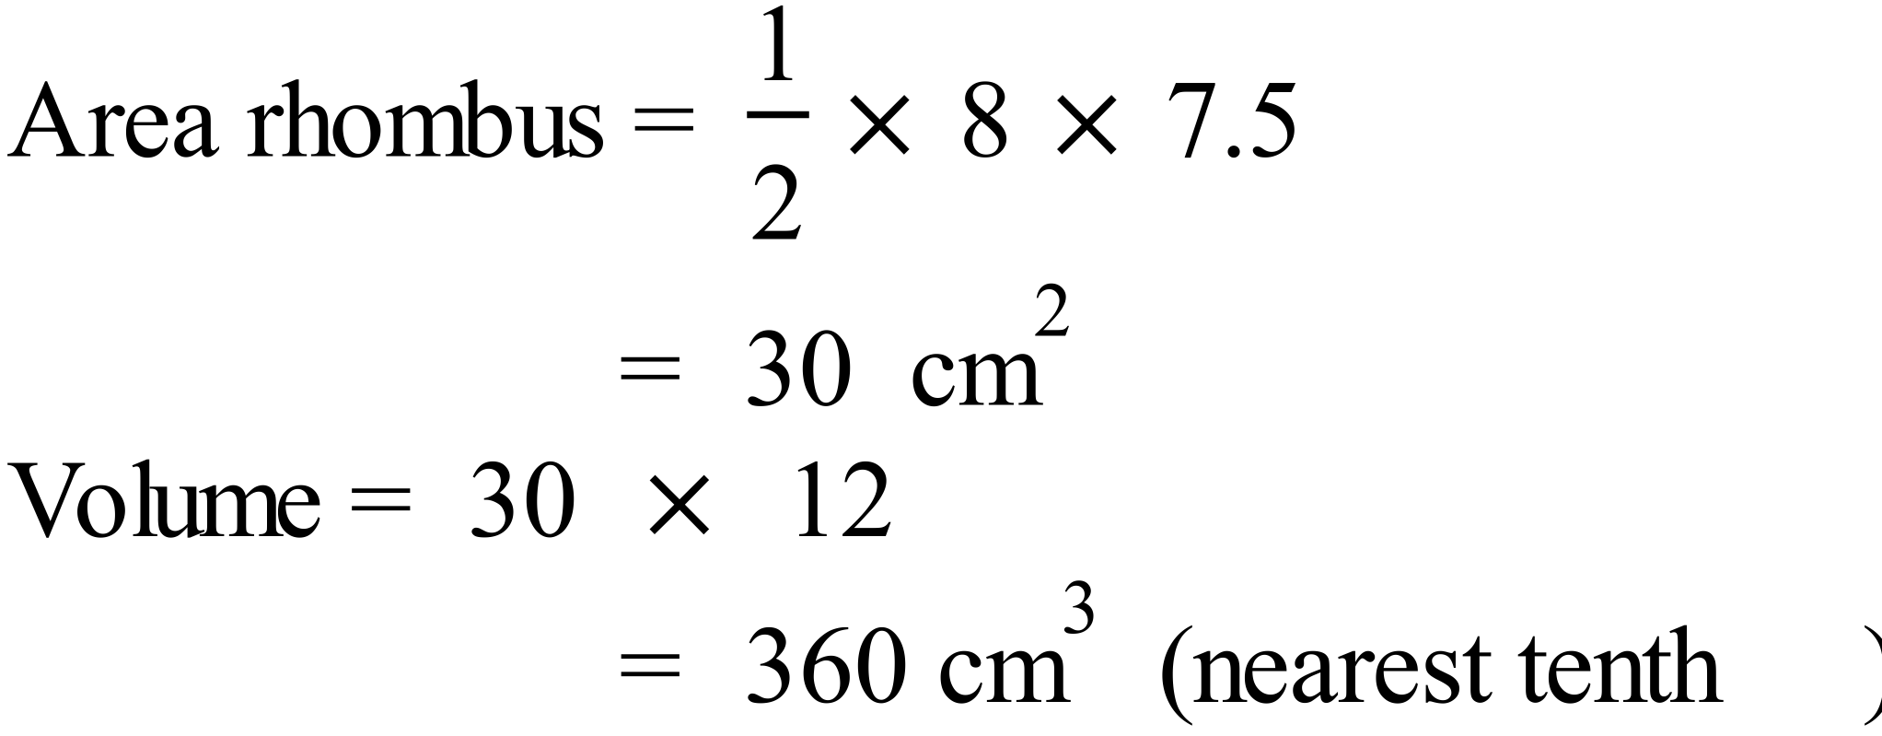 |  |  | 4th answer
 | 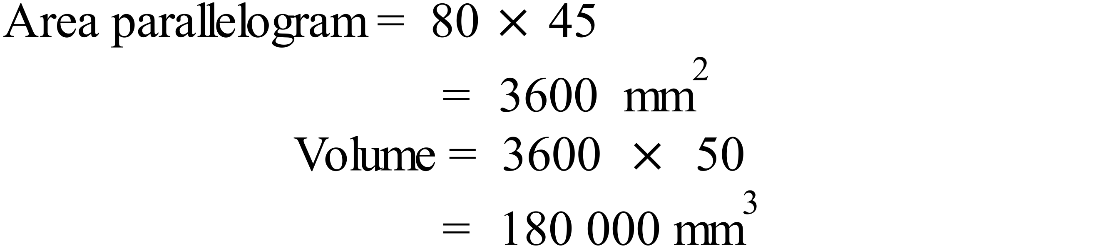 |  |  | 180 000 mm³
 | 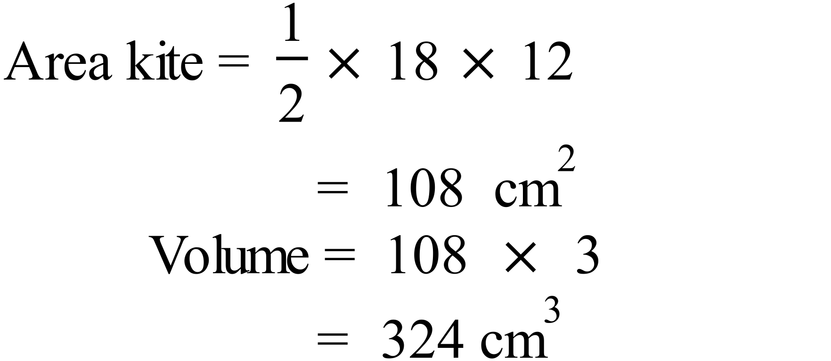 |  |  | 324 cm³
 | 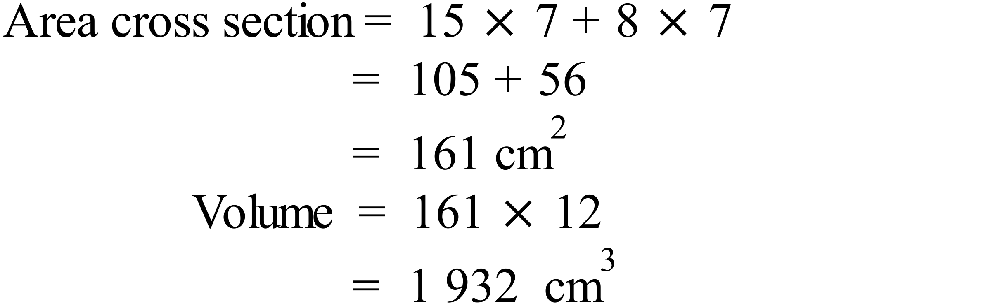 |  |  | 3rd answer
 | 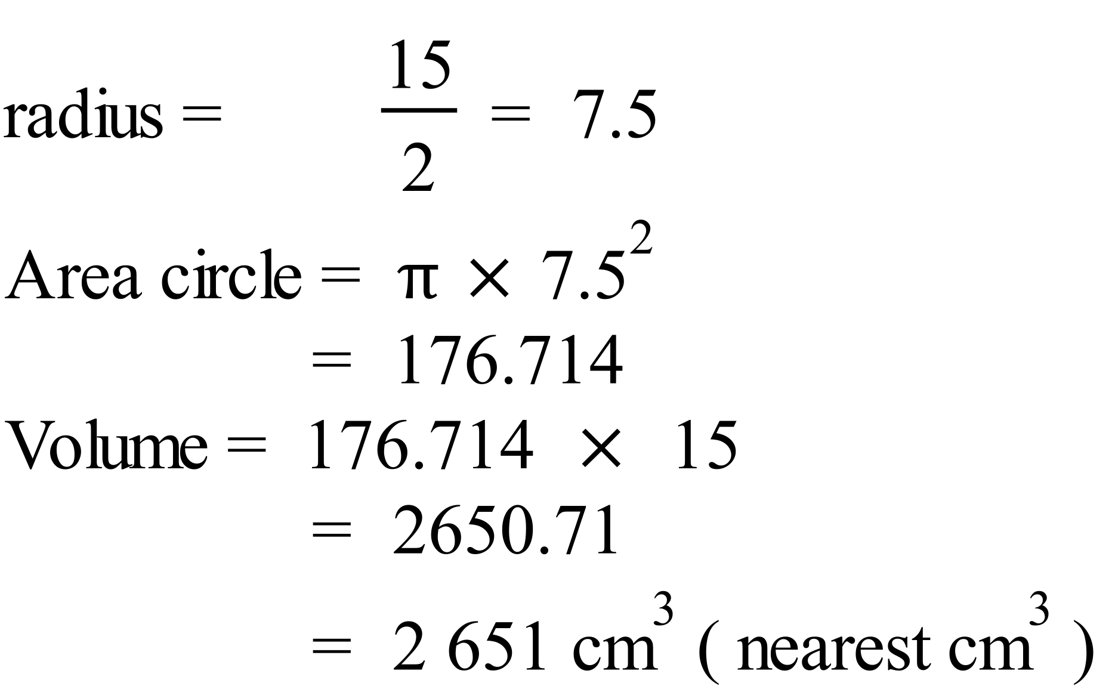 |  |  | 2nd answer
 | 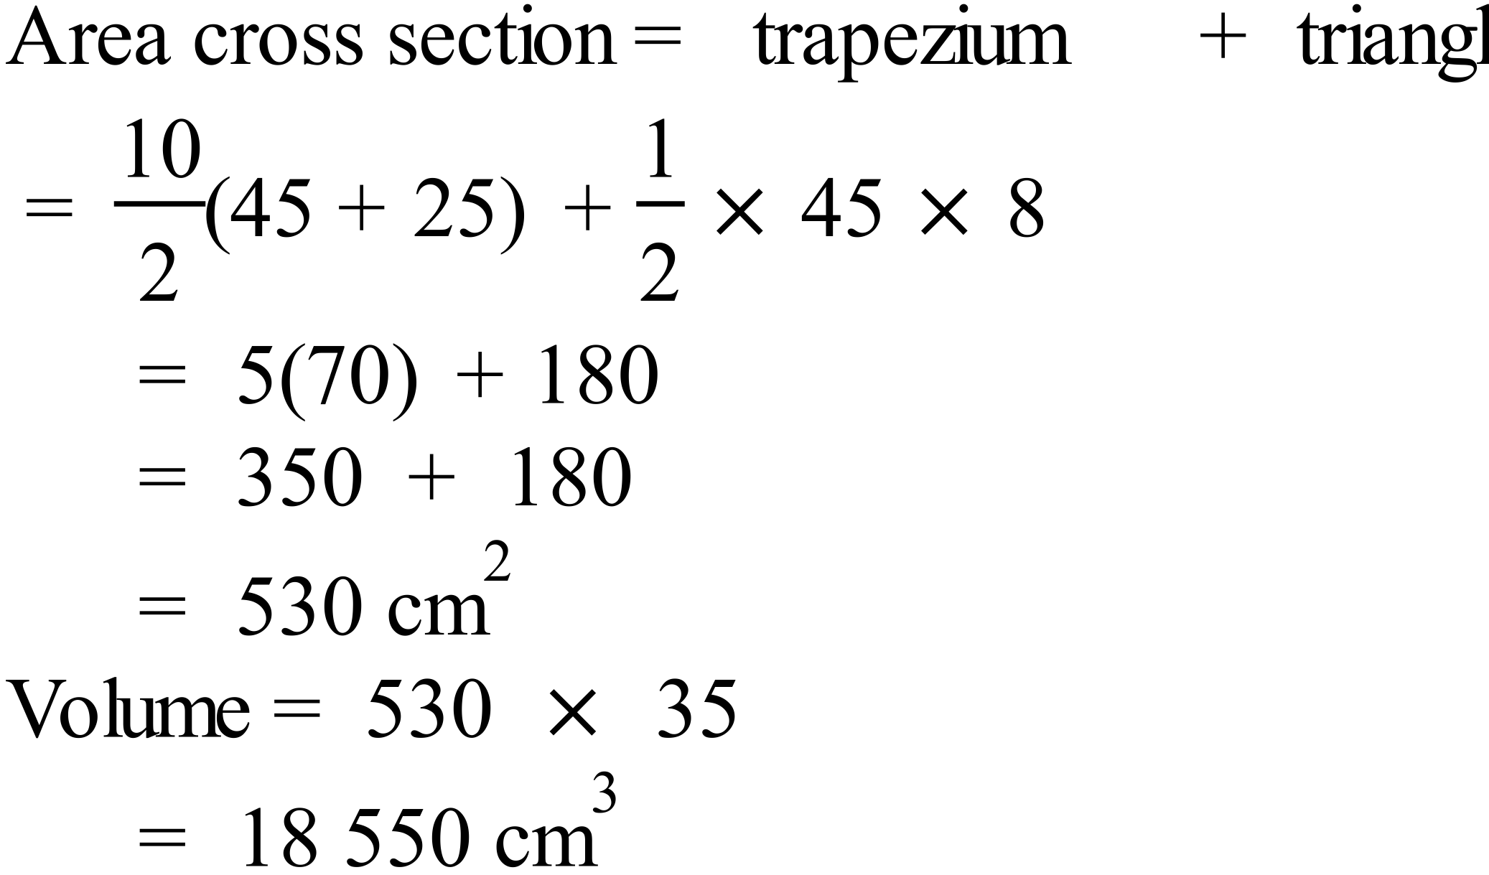 |  |  | 1st answer
 | 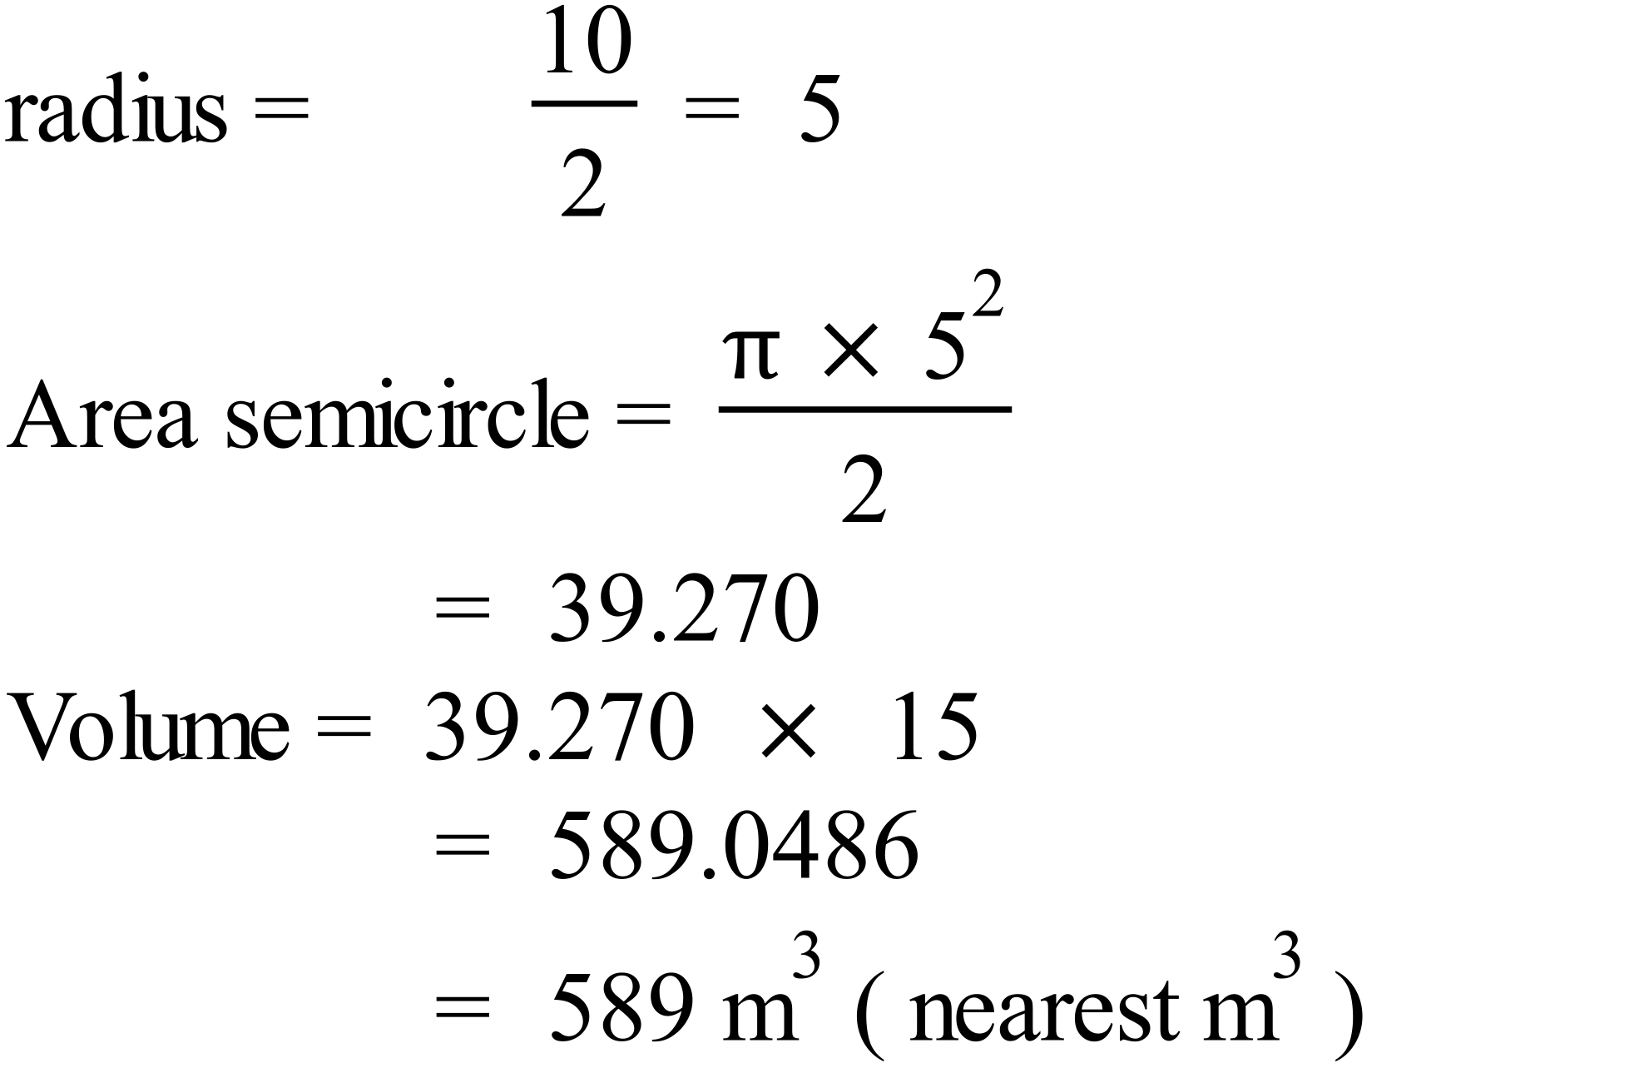 |  |  | 589 m³
 | 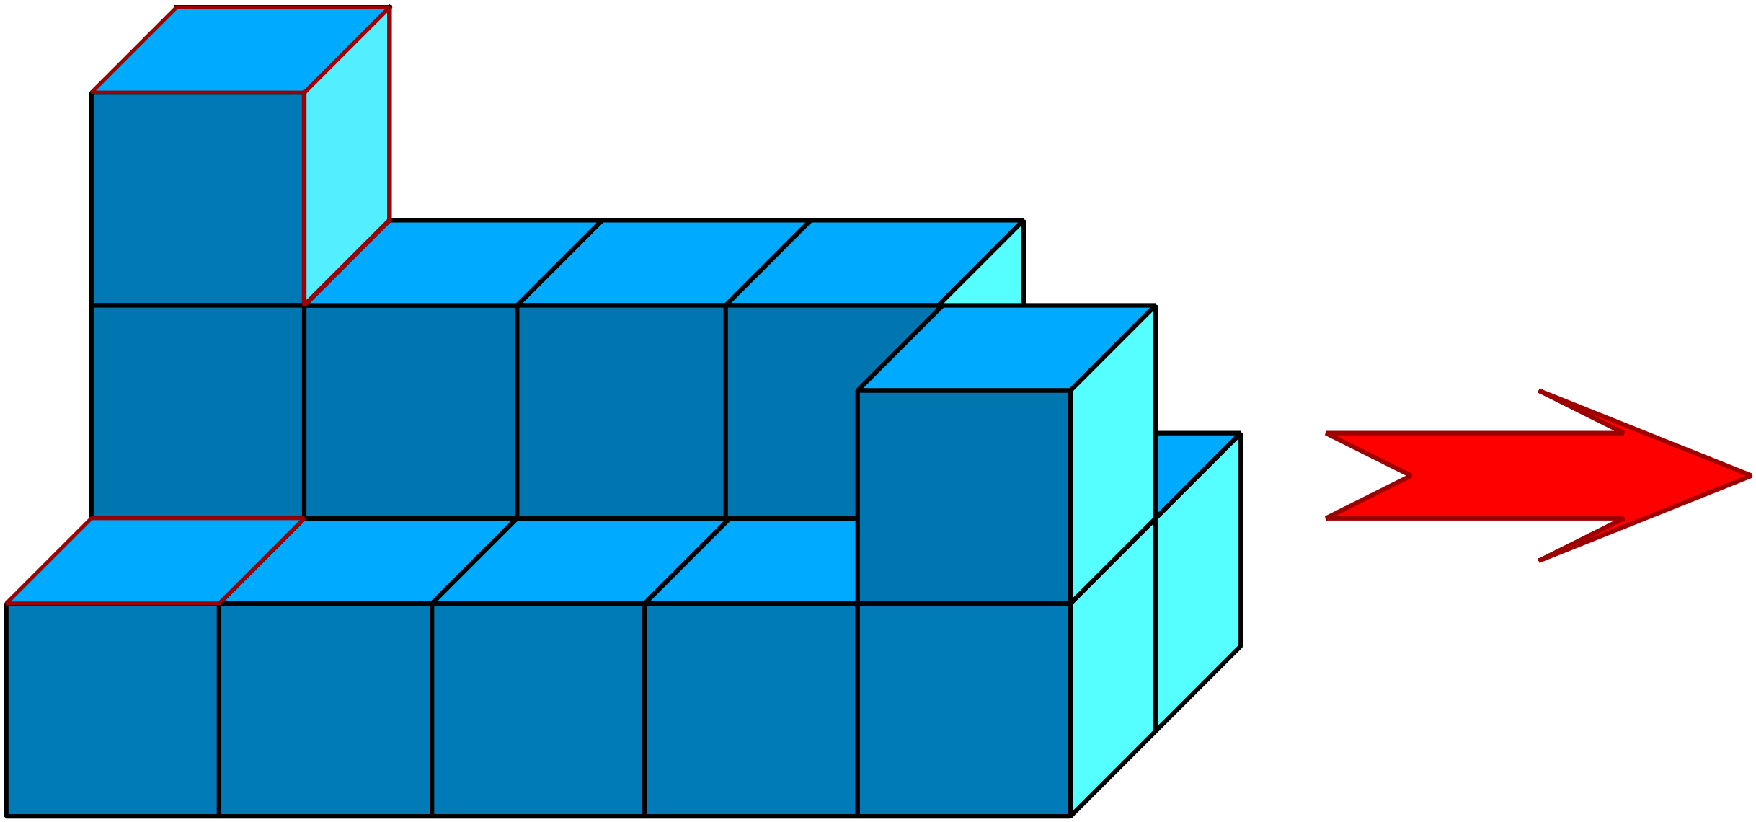  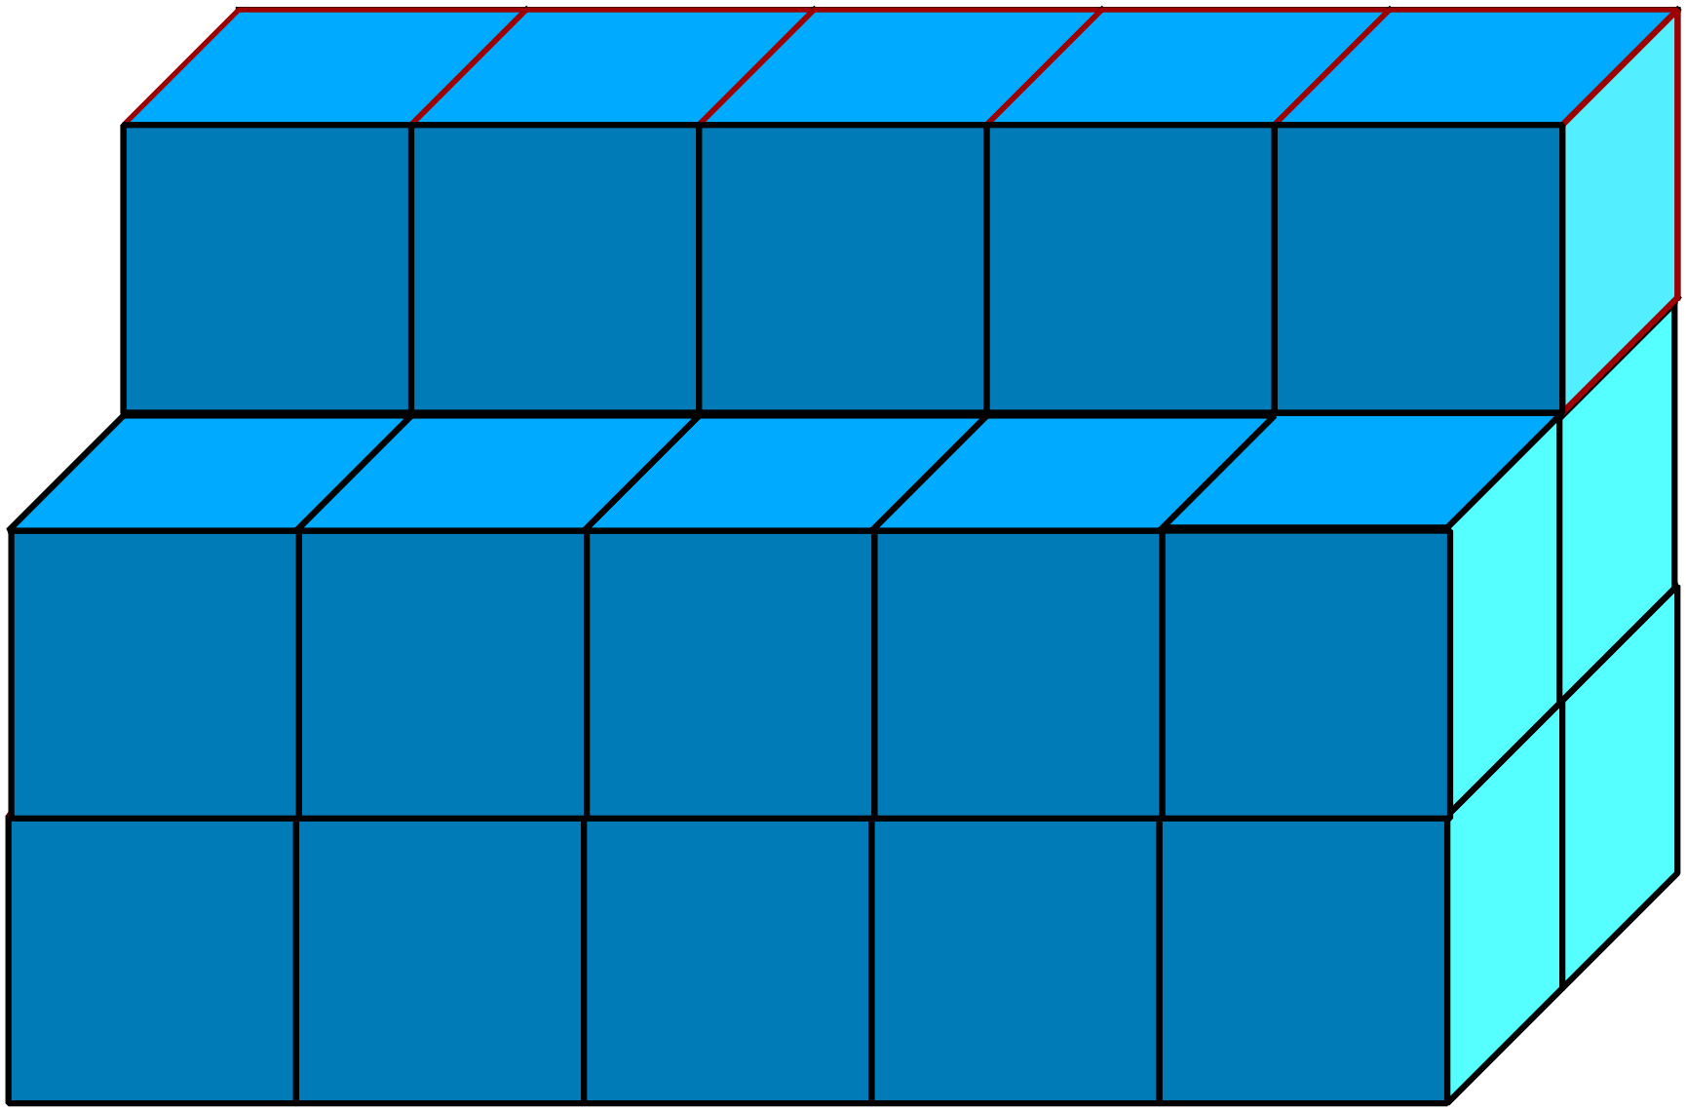  Extra needed 5 on second row and 4 on top row to make a prism.  Total needed = 9 cubes. |  |  | 9 cubes
 | 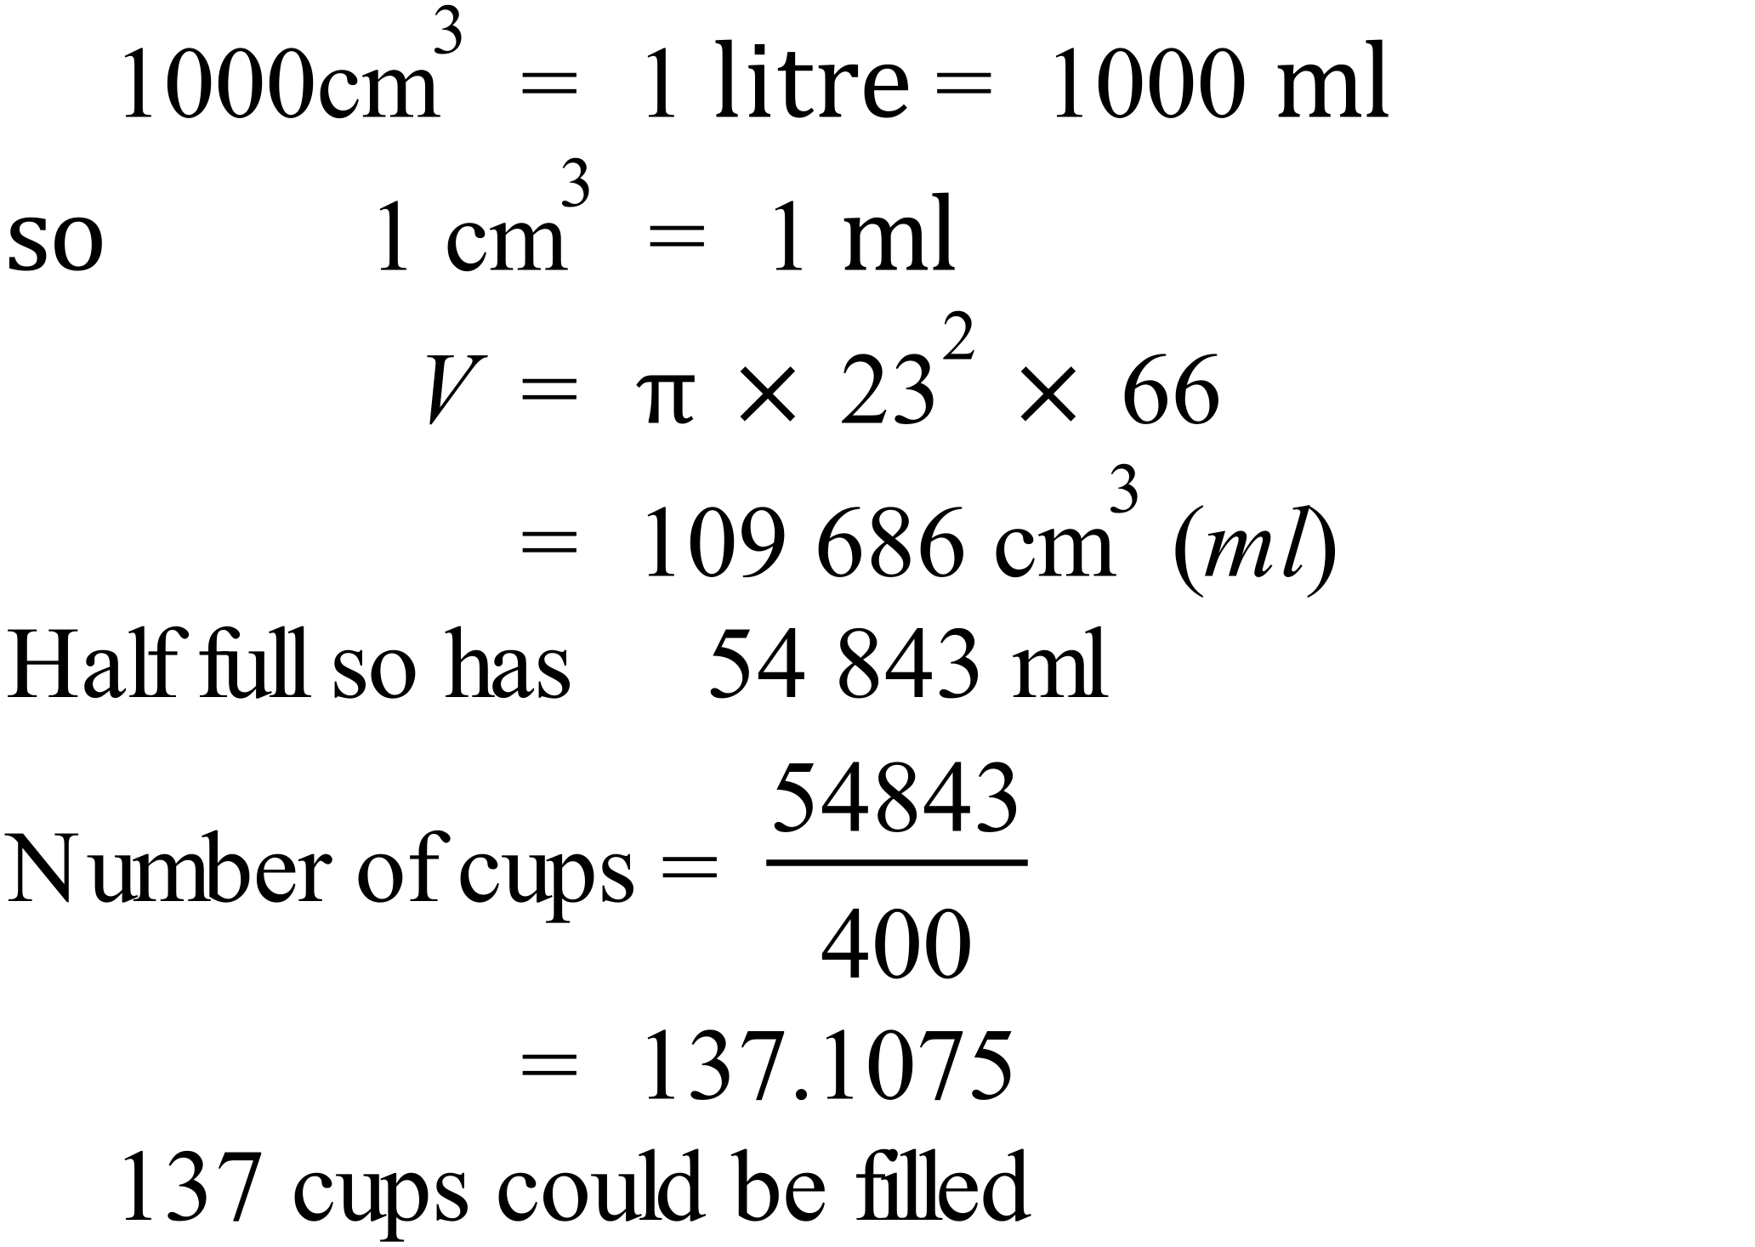 |  |  | 137 cups

